**SCHOOL OF DIGITAL MEDIA AND INFOCOMM TECHNOLOGY (DMIT)**

|  |  |
| --- | --- |
| **Date of Submission:** | 24 June 2018 |

|  |  |
| --- | --- |
| **Prepared for:** | Ms Lin Zhao |

|  |  |
| --- | --- |
| **Class:** | DISM/FT/3A/03 |

|  |  |
| --- | --- |
| **Submitted by:** | Joshua Lee |

|  |  |
| --- | --- |
| **Student ID** | **Name** |
| 1625439 | Joshua Lee |

**IOT CA1**

**Step-by-step Tutorial**

**DIPLOMA IN BUSINESS INFORMATION TECHNOLOGY**

**DIPLOMA IN INFORMATION TECHNOLOGY**

**DIPLOMA IN INFOCOMM SECURITY MANAGEMENT**

**ST0324 Internet of Things (IOT)**

**2017/2018 Semester 1**

**Table of Contents**

Section 1 Overview of the application 2

A. What is the application about? 2

B. Summary of the steps that will be described 4

C. How does the final RPI set-up looks like? 4

D. How does the web application look like? 5

Section 2 Hardware requirements 6

Hardware checklist 6

A. PiCam 6

B. I2C LCD Screen 6

C. DHT11 Temperature and Humidity Sensor 7

D. Buzzer 7

E. Buttons (1x White, 1x Red) 8

F. 10K Ohms Resistor for Buttons (2x) 8

G. LED (1x Green, 1x Red, 1x Yellow) 9

H. 330 Ohms Resistor for LEDs (3x) 9

Section 3 Install the Necessary Hardware 10

A. Installing the LCD Display 10

B. Installing the Red and Green LEDs 11

C. Installing the Red and White Buttons 14

D. Installing the Buzzer 17

E. Installing the DHT11 Sensor 18

F. Installing the Yellow LED 19

Section 4 Code the Program 21

A. Install the Necessary Software 21

B. Code the Program 26

Section 5 Testing the Software 56

A. atmosphere.py 56

B. startprogram.py 57

C. server.py 59

# Section 1 Overview of the application

* 1. What is the application about?

For my IOT CA1, I have come up with a security solution for a safe room using the Raspberry Pi 3. In order to access the safe room, the use will required to complete a Two Factor Authentication (2FA).

Firstly, there LCD screen will prompt the user to press the red button in order to start the authentication sequence.

Next, the LCD screen will prompt the user for a password combination in the form of button presses must be entered into the device, allowing the user to move on to the second step of authentication. The password can be of any length and of any sequence of any of the two white or red buttons. If the user fails the password combination, the red LED light will light up and the buzzer will sound, and the screen will prompt that the user has entered the wrong passcode. However, if the user enters the correct passcode, the red LED light will light up and the buzzer will sound as well. Once the passcode is correct, the LCD screen will prompt that the user has entered the right password, and will initiate the facial recognition, which will be the second factor of authentication

The camera attached to the device will do a facial scan of the person attempting to enter the room. There is a 30 second time limit for the facial recognition. If the camera does not recognise the user or the time limit is up, the camera will take an image and store it into the Raspberry Pi. On the other hand, if there is a confidence of at least 40% (the number can be changed), the device will authenticate the user and allow him to enter the room. Again, the green LED light will light up, the buzzer will sound and the LCD screen will address the user by their name, welcoming them into the room.

In the room, there will be a yellow LED light for the room’s lighting source, and a temperature and humidity sensor. The LED light can be controlled by the red button to either turn it on or off.

The device will also be serving a web application that will be the main administration for the whole solution.

On the webpage, there are four categories:

1. Room Light Switch

2. Room Atmosphere

3. Room Entry Logs

4. Security Settings

The Room Light Switch will allow the user to turn the yellow LED light on and off remotely over the web application.

Room Atmosphere has two options: to view current real time temperatures and humidity of the room, or to view historical data of the temperatures and humidity of the room during a certain date.

The Room Entry Logs keep track of the date and time of users that have entered the room, as well as the time and image captures of failed entry logs.

The Security Settings is where the user can change the passcode combination, the face unlock confidence, as well as register another user’s face into the database.

* 1. Summary of the steps that will be described

Provide a bullet list of the steps that will be covered in the other parts of this tutorial

|  |  |  |
| --- | --- | --- |
|  | Section | Description |
|  | Overview |  |
|  |  |  |
| Sections 2 to 5 provides the step-by-step instructions to set up the application | | |
|  | Hardware Requirements | Provides overview of hardware required |
|  | Install the Necessary Hardware | How to setup all the necessary hardware onto the Raspberry Pi |
|  | Code the Program | The Python, Flask and HTML codes that will be required for the solution, and the required installations for the project to run |
|  | Testing the Software | How to run the software to test the program |

* 1. How does the final RPI set-up looks like?

After following this tutorial, your Raspberry Pi should look like this:

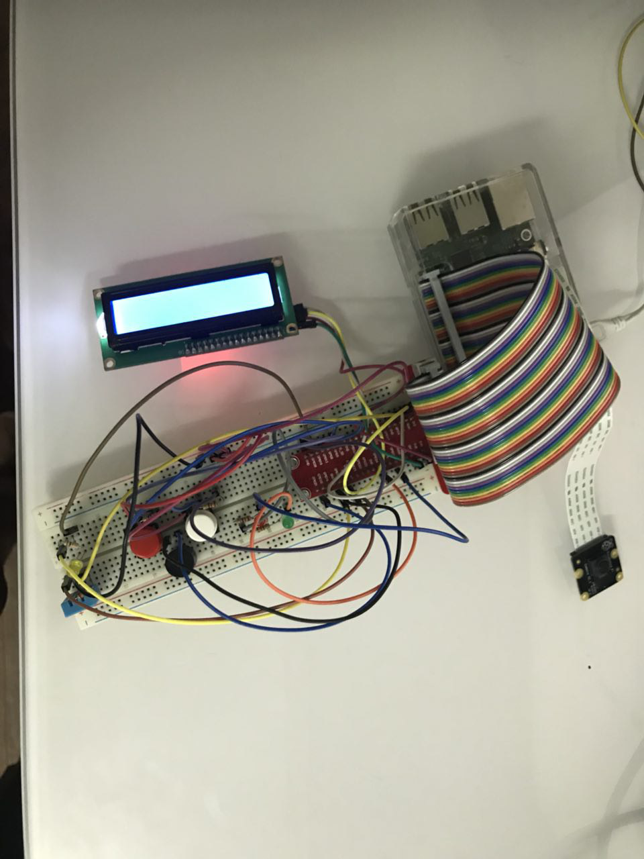

* 1. How does the web application look like?

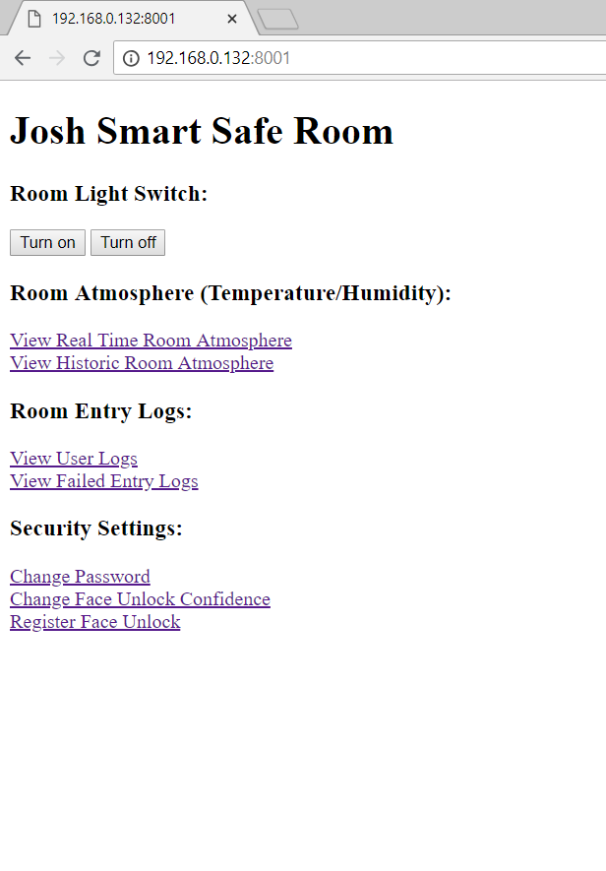

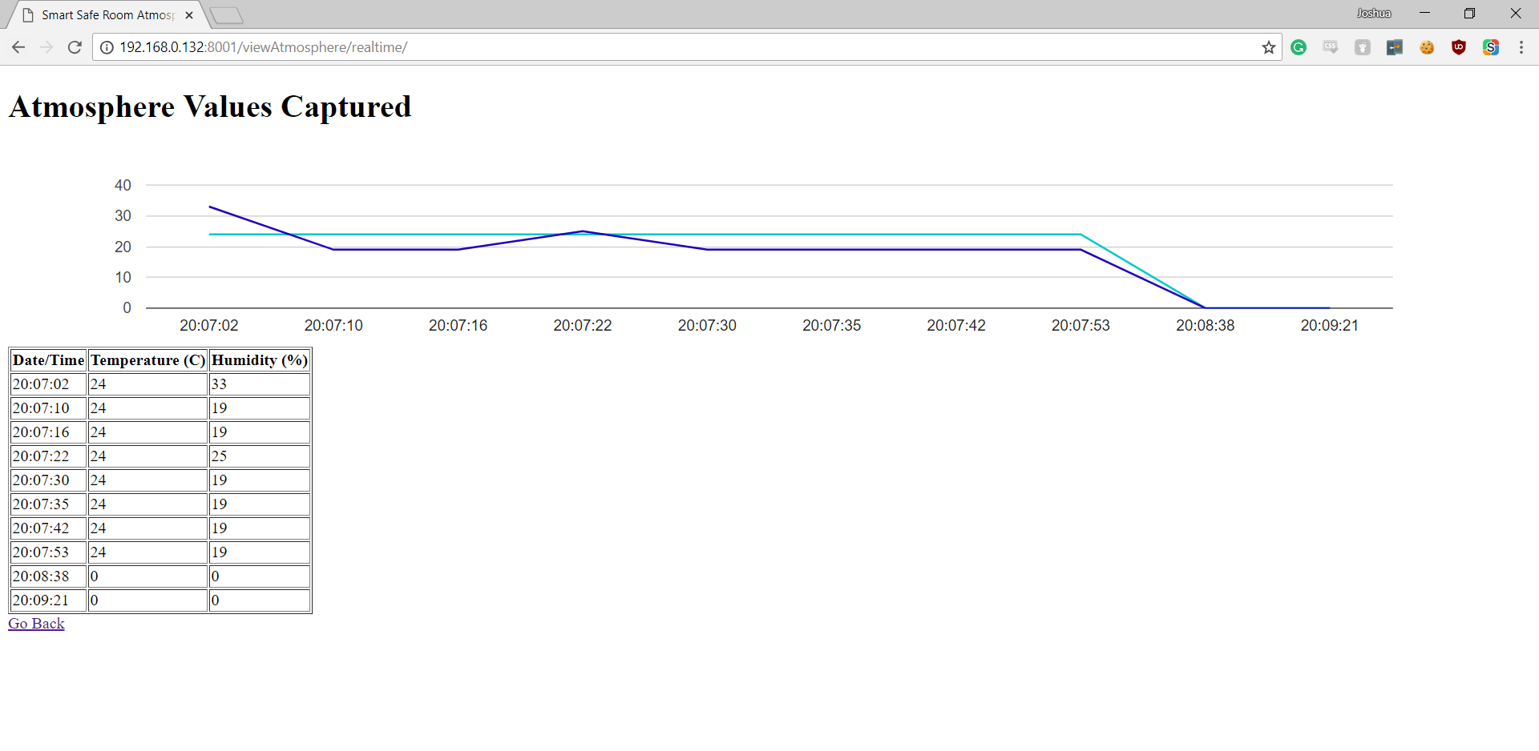

# Section 2 Hardware requirements

Hardware checklist

## PiCam

|  |  |  |
| --- | --- | --- |
|  | Description | |
|  | * The Raspberry Pi camera is an official accessory that hooks up to a special connector on the Raspberry Pi. * It can be used on any model of the Raspberry Pi except the first version of Pi Zero * The camera is mounted on a small printed circuit board and connects through a ribbon cable. * The connector provides direct access between the camera and the processor. This is more efficient than using a webcam, which needs to connect through the USB protocol * The picture on the right shows the camera connected to a Raspberry Pi. | **piCam** |

## I2C LCD Screen

|  |  |  |
| --- | --- | --- |
|  | Description | |
|  | * Adding a LCD display in your IoT projects will definitely spice it up by one notch! LCD displays are a fun and easy way to have your microcontroller project talk back to you. * LCDs are available in tons of colors and sizes. For example, you might have 8x1 LCDs or 20x4 LCDs * For this lab, we will use the commonly available 16x2 LCD which can display up to 32 characters. * We will use the i2C version which require you to connect only 2 GPIO pins to your Raspberry Pi. * If you are buying your own LCDs, do make sure you buy the i2C version though they might cost a bit more. The non-i2C versions require you to connect double the number of GPIO pins! | **i2c LCD Screen** |

## DHT11 Temperature and Humidity Sensor

|  |  |  |
| --- | --- | --- |
|  | Description | |
|  | * The DHT11 is a basic, ultra low-cost digital temperature and humidity sensor. * It uses a capacitive humidity sensor and a thermistor to measure the surrounding air, and spits out a digital signal on the data pin (no analog input pins needed). * Its fairly simple to use, but requires careful timing to grab data. * The only real downside of this sensor is you can only get new data from it once every 2 seconds * The sensor that has been given to you has 4 pins.   + VCC – this is the one you connect to power   + DATA – this is an output value you read to determine the temperature   + NC – Stands for no connection   GND – this is the one you connect to ground | **DHT11** |

## Buzzer

|  |  |  |
| --- | --- | --- |
|  | Description | |
|  | A buzzer is an audio signaling device which is commonly found in circuits to create a buzzing or beeping noise.  Buzzers can be categorized as active buzzers and passive ones. For our lab, we will use active buzzers as they are a lot simpler to use than passive ones though they are slightly more expensive.  An active buzzer can be connected just like an LED but they are even easier to use because a resistor is not needed.  A buzzer typically has 2 pins   * + VOUT – Connect this to a GPIO pin to control its value * GND – Connect this to ground | **Buzzer** |

## Buttons (1x White, 1x Red)

|  |  |  |
| --- | --- | --- |
|  | Description | |
|  | * The picture here shows a tactile push-button * Note that it has 4 'legs'. These legs are the ones that send the signals. * Push-buttons act as sensors (inputs) * To know whether a push-button is pressed or unpressed, we can detect its HIGH or LOW state, which are passed through the 'legs' | **BUTTON** |

## 10K Ohms Resistor for Buttons (2x)

|  |  |  |
| --- | --- | --- |
|  | Description | |
|  | Adding a button to the circuit can introduce irregularities in the current flow to the RPi and damage our RPi  To ensure our RPi stays safe, we will be adding a 10K Ω **pull-down** resistor to moderate the current flow through the button. You can recognise the 10K ohms resistor by its color bands (brown-black-orange-gold)  Note that when the pull-down resistor is used in the circuit, it will change the current flow as follows:   * When the button is pressed: A small current flows through the input pin connected to the button, and the pin will read HIGH * When the button is unpressed: The current passes through the resistor and directly to GND pin. There is no current passing through the input pin and thus it will read LOW | **10K Ω RESISTOR** |

## LED (1x Green, 1x Red, 1x Yellow)

|  |  |  |
| --- | --- | --- |
|  | Description | |
|  | * The longer leg (anode) should be connected to the positive supply of the circuit (power) * The shorter leg (cathode) should be connected to the negative side of the power supply (ground) * LEDs will only work if power is supplied the correct way round * You will not break the LEDs if you connect them the wrong way – they just don’t light.   If the LED doesn’t light when you finish your lab later, maybe you have connected it the wrong way | **LED** |

## 330 Ohms Resistor for LEDs (3x)

|  |  |  |
| --- | --- | --- |
|  | Description | |
|  | * Resistors are a way of limiting the amount of electricity going through a circuit; specifically, they limit the amount of ‘current’ that is allowed to flow. * The measure of resistance is called the Ohm (Ω), and the larger the resistance, the more it limits the current.   It does not matter which way round you connect the resistors. Current flows in both ways through them. |  |
|  | * Resistors can range from 100Ω to 10000Ω * The value of a resistor is marked with coloured bands along the length of the resistor body. * In this lab, you will be using a **330Ω** resistor. * You can identify the 330Ω resistors by the colour bands along the body. The colour coding will depend on how many bands are on the resistors supplied: * For example, on a four color band resistors, a 330Ω resistor is colored Orange, Orange, Brown, and then Gold. On a five color band 330Ω resistor, the colours are Orange, Orange, Black, Black, Brown. | <https://www.allaboutcircuits.com/tools/resistor-color-code-calculator/>  **330 ohms RESISTOR**    Figure 1: Orange,Orange,Brown |

# Section 3 Install the Necessary Hardware

## Installing the LCD Display

|  | LCD Display | |
| --- | --- | --- |
|  | Connect the pins on the LCD to the RPi as follows:   |  |  |  | | --- | --- | --- | | **Jumper color** | **LCD pin** | **RPi pin** | | White | SCL | SCL | | Yellow | SDA | SDA | | Black | GND | GND | | Red | VCC | 5V | |  |

This is how your completed circuit should look like after installing the LCD display on to the Raspberry Pi.

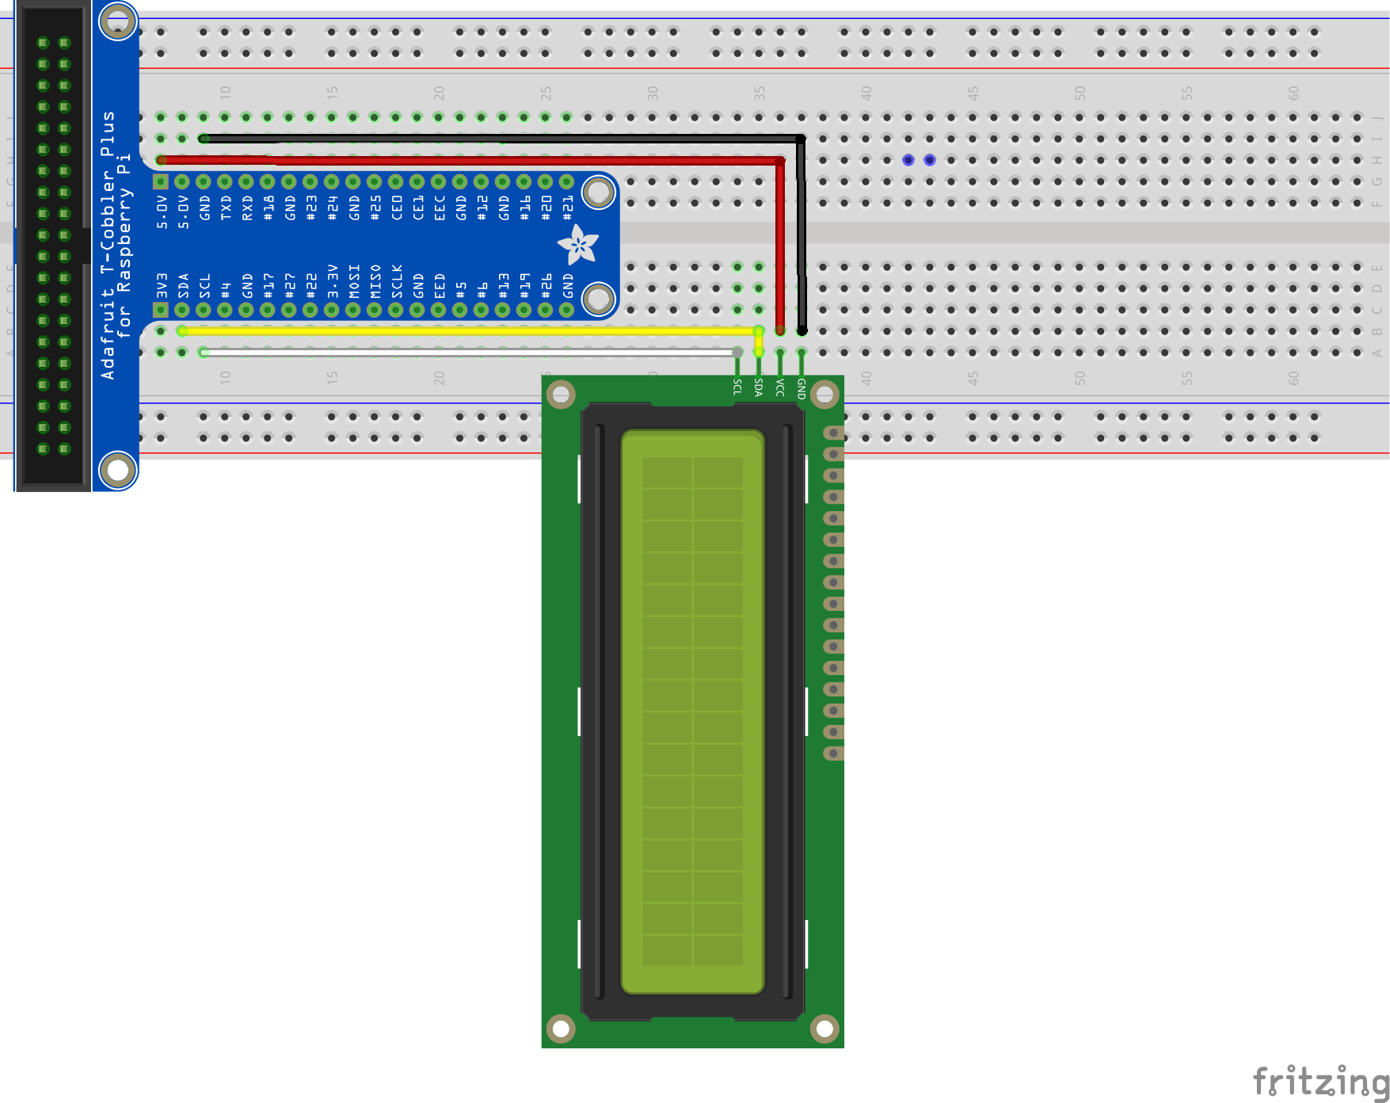

## Installing the Red and Green LEDs

This is how your completed circuit should look like after installing the red LED:

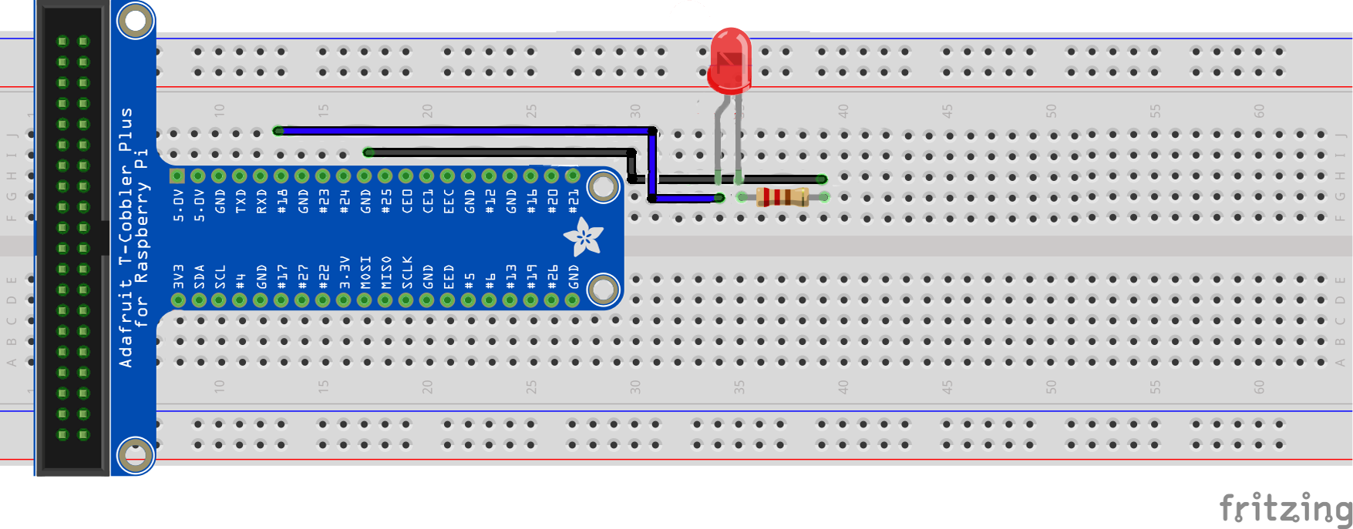

Do note that there are some overlaps in the fritizing diagram. This is because we will be sharing the ground cable for the green LED as well, and to converse as much space as we can, as this project is actually quite extensive!

|  |  |
| --- | --- |
| CONNECT RED LED AND RESISTOR | |
|  | Plug in the LED into the breadboard as shown. Place the longer end of the LED nearer to the T-Cobbler Kit. |
|  | Plug in the **330 Ω** resistor into the breadboard as shown. One end of the resistor should be in the same column as the short leg of the LED. |
|  | **LED**   1. Using a **blue** cable, connect the long end of LED to **BCM18** |
|  | **Resistor (Orange-Orange-Brown)**   1. Using a **black** cable, connect the free end of the 330 Ω resistor to GND |

This is how your completed circuit should look like after installing the green LED:

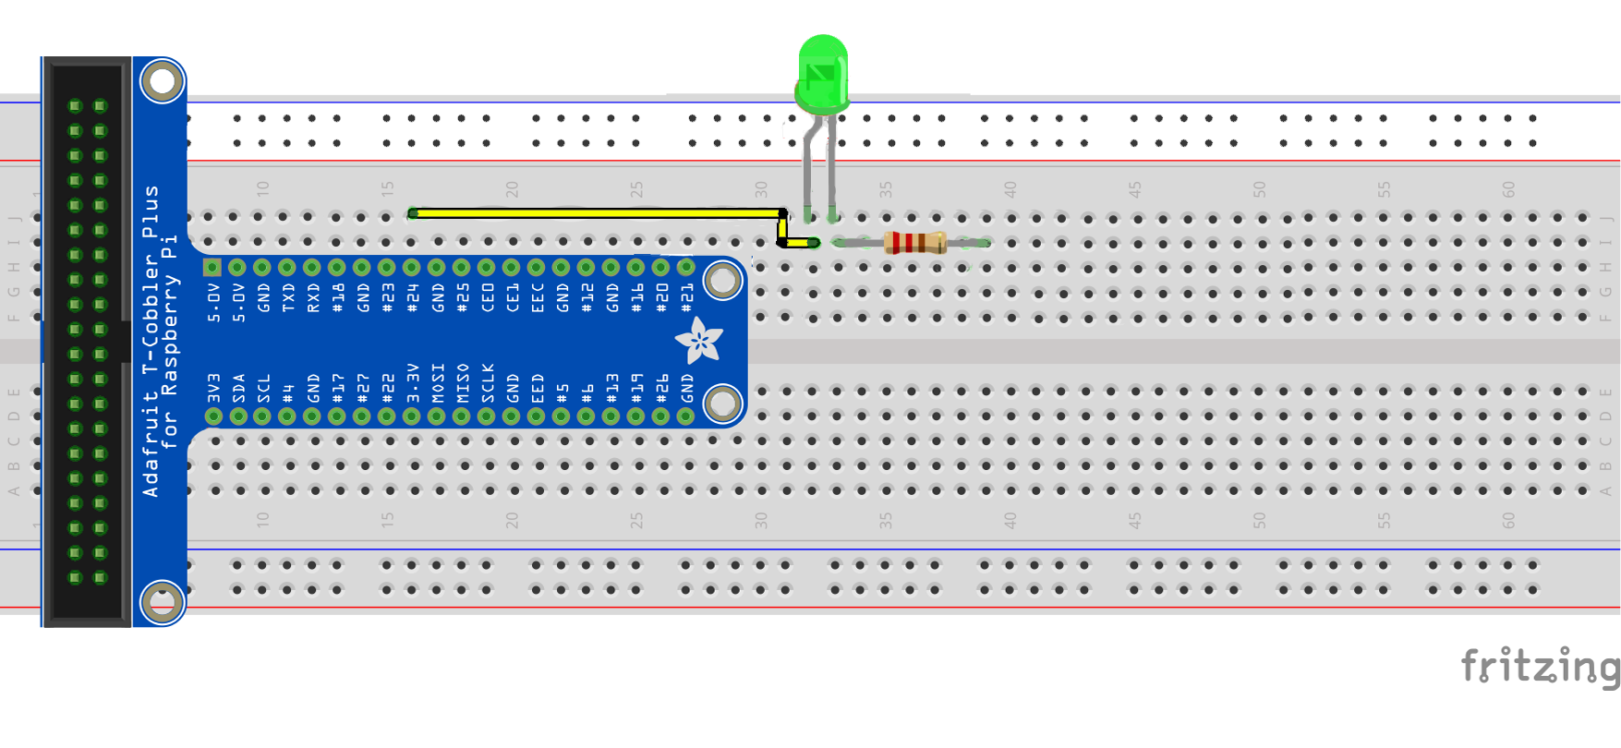

If you noticed, there will definitely be an overlap between the jumper cables for the green LED and the red LED. However, it is not an issue. It will only affect the fritizing diagram.

|  |  |
| --- | --- |
| CONNECT GREEN LED AND RESISTOR | |
|  | Plug in the LED into the breadboard as shown. Place the longer end of the LED nearer to the T-Cobbler Kit. |
|  | Plug in the **330 Ω** resistor into the breadboard as shown. One end of the resistor should be in the same column as the short leg of the LED. |
|  | **LED**   1. Using a **yellow** cable, connect the long end of LED to **BCM24** |
|  | **Resistor (Orange-Orange-Brown)**   1. Using a **black** cable, connect the free end of the 330 Ω resistor to GND |

The result of the green and red LED will look like this:

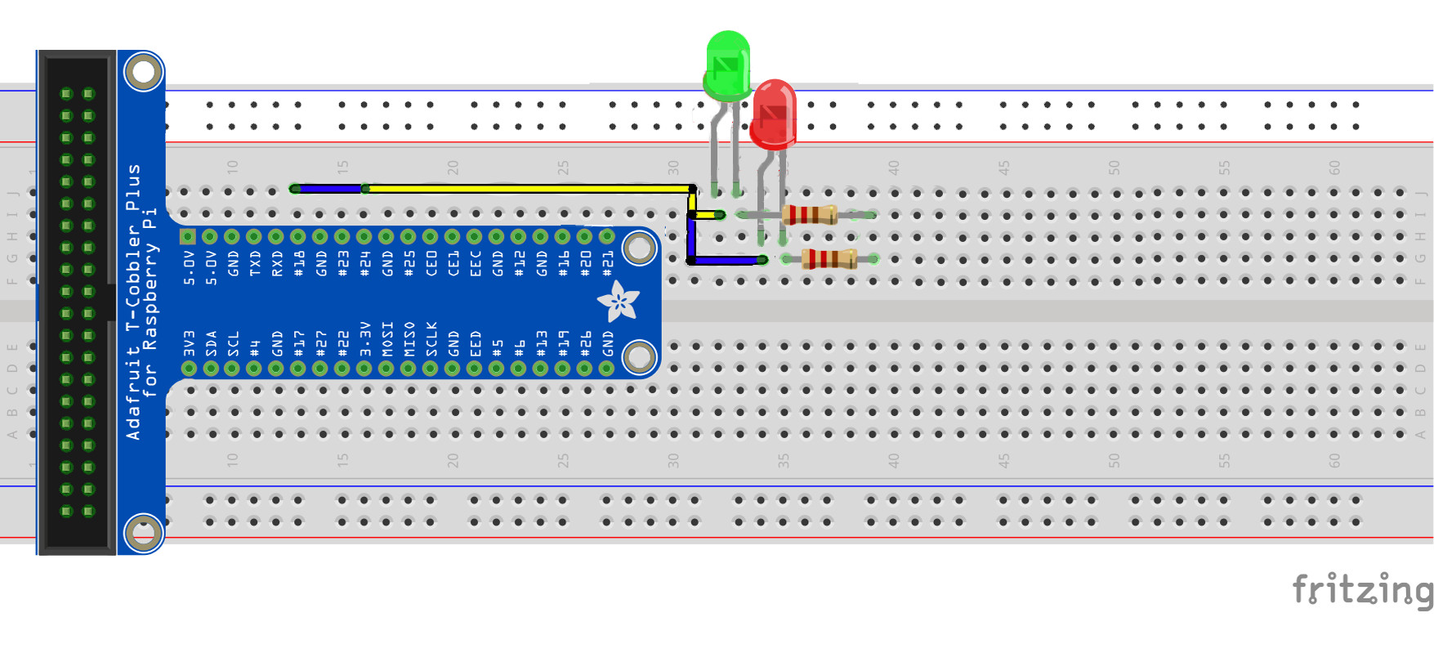

## Installing the Red and White Buttons

This is how your completed circuit should look like after installing the white button:

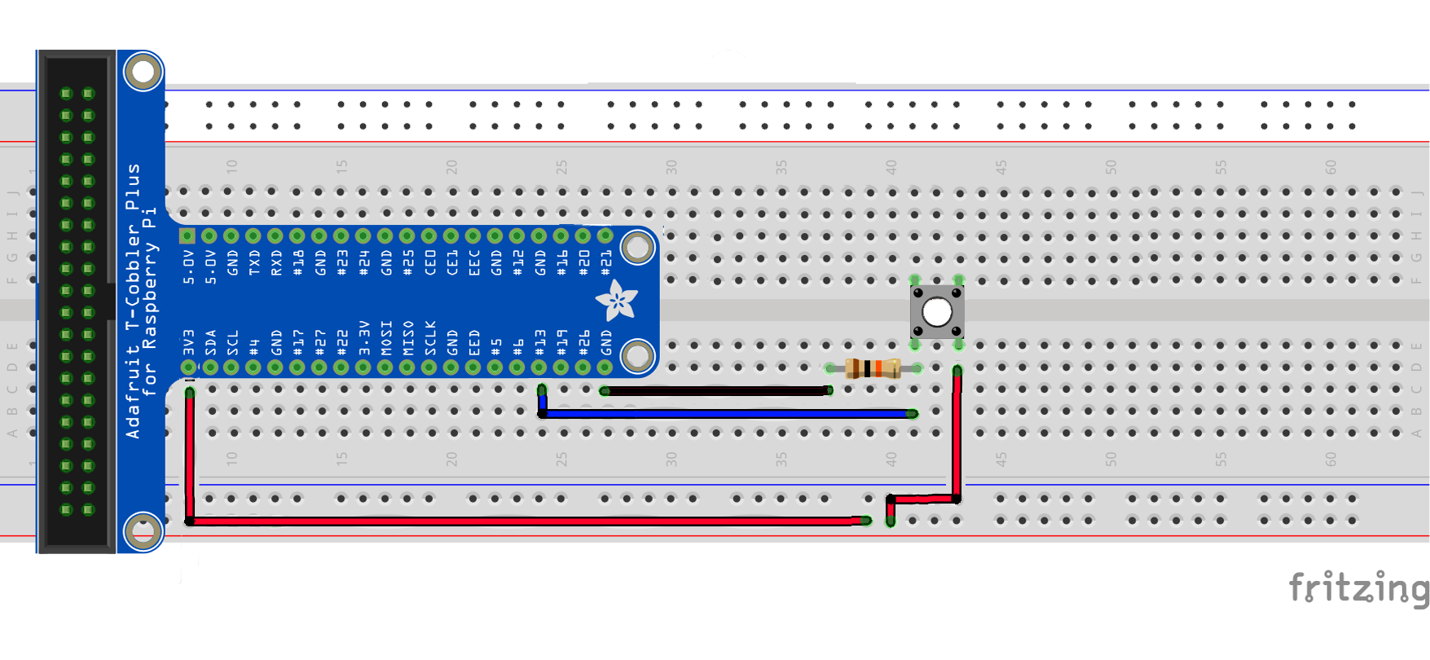

|  |  |
| --- | --- |
| CONNECT WHITE BUTTON AND RESISTOR | |
|  | Place the button on the breadboard as shown |
|  | Plug in the **10K Ω** resistor into the breadboard as shown. One end of the resistor should be in the same column as the left pin of the button. |
|  | **Button**   1. Using a **blue** cable, connect the left pin of the push button to **BCM13** 2. Using a **red** cable, connect the right pin of the push button to 3.3V |
|  | **10K** Ω **Resistor (Brown-Black-Orange)**   1. Using a **black** cable, connect the free end of the 10K Ω resistor to GND |

This is how your completed circuit should look like after installing the red button:

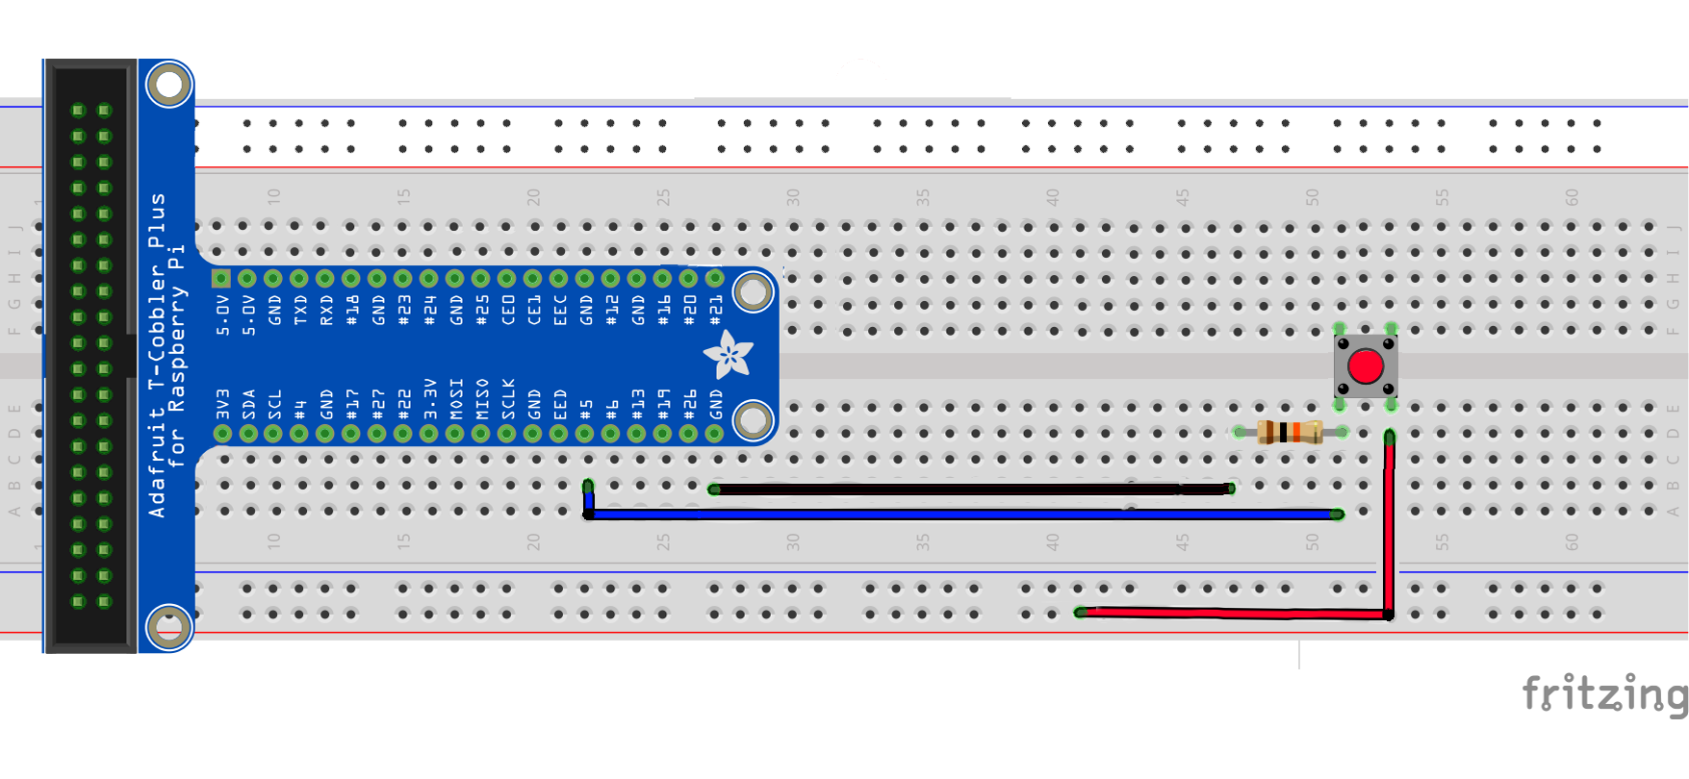

|  |  |
| --- | --- |
| CONNECT RED BUTTON AND RESISTOR | |
|  | Place the button on the breadboard as shown |
|  | Plug in the **10K Ω** resistor into the breadboard as shown. One end of the resistor should be in the same column as the left pin of the button. |
|  | **Button**   1. Using a **blue** cable, connect the left pin of the push button to **BCM13** 2. Using a **red** cable, connect the right pin of the push button to 3.3V |
|  | **10K** Ω **Resistor (Brown-Black-Orange)**   1. Using a **black** cable, connect the free end of the 10K Ω resistor to GND |

After this, your circuit should look like this:

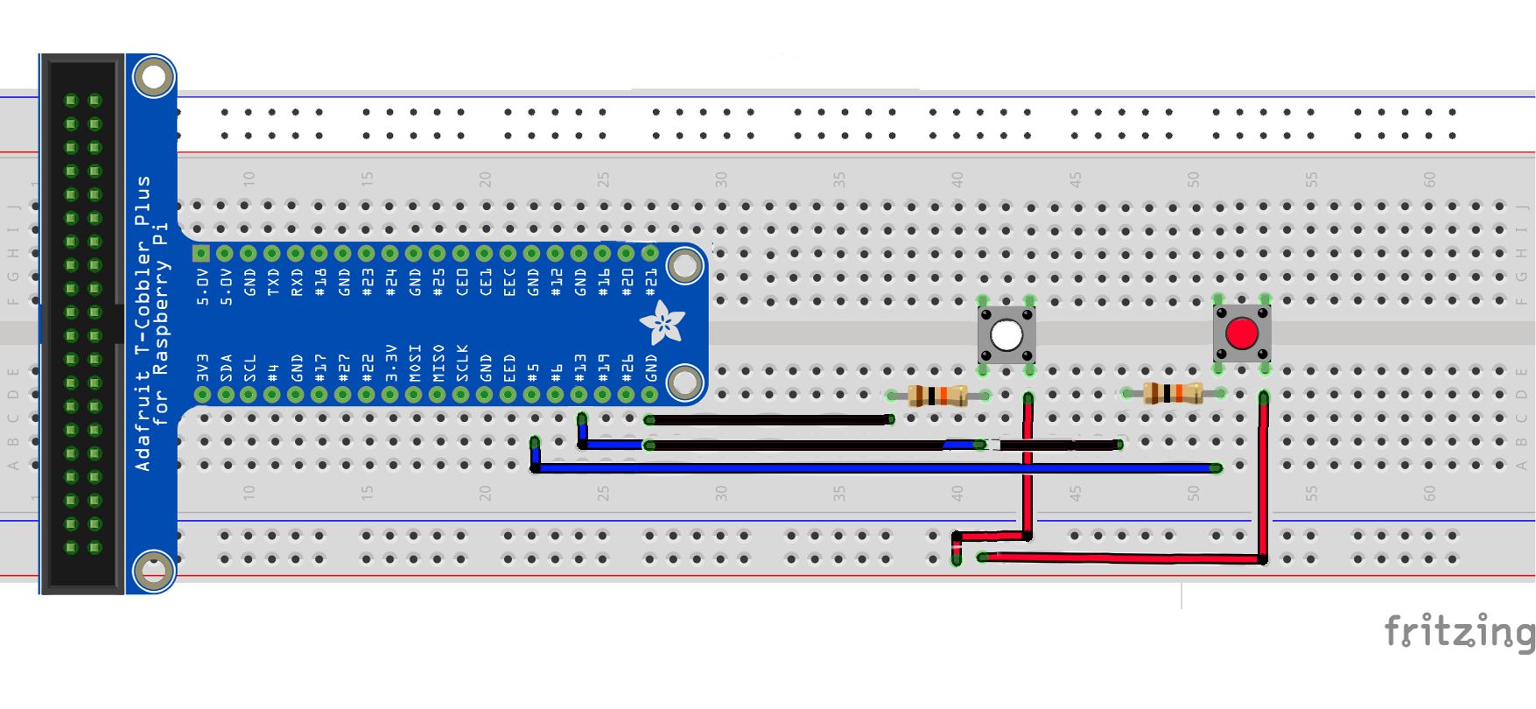

Do note that the blue jumper cable for the white button ends in the middle of the ground jumper cable for the red button.

The circuit along with the LEDs should now look like this:

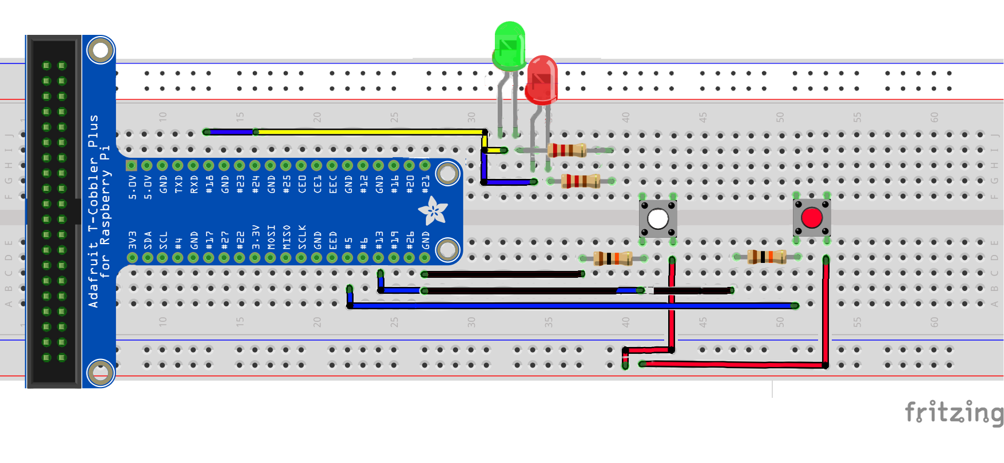

## Installing the Buzzer

This is how your completed circuit should look like after installing the buzzer:

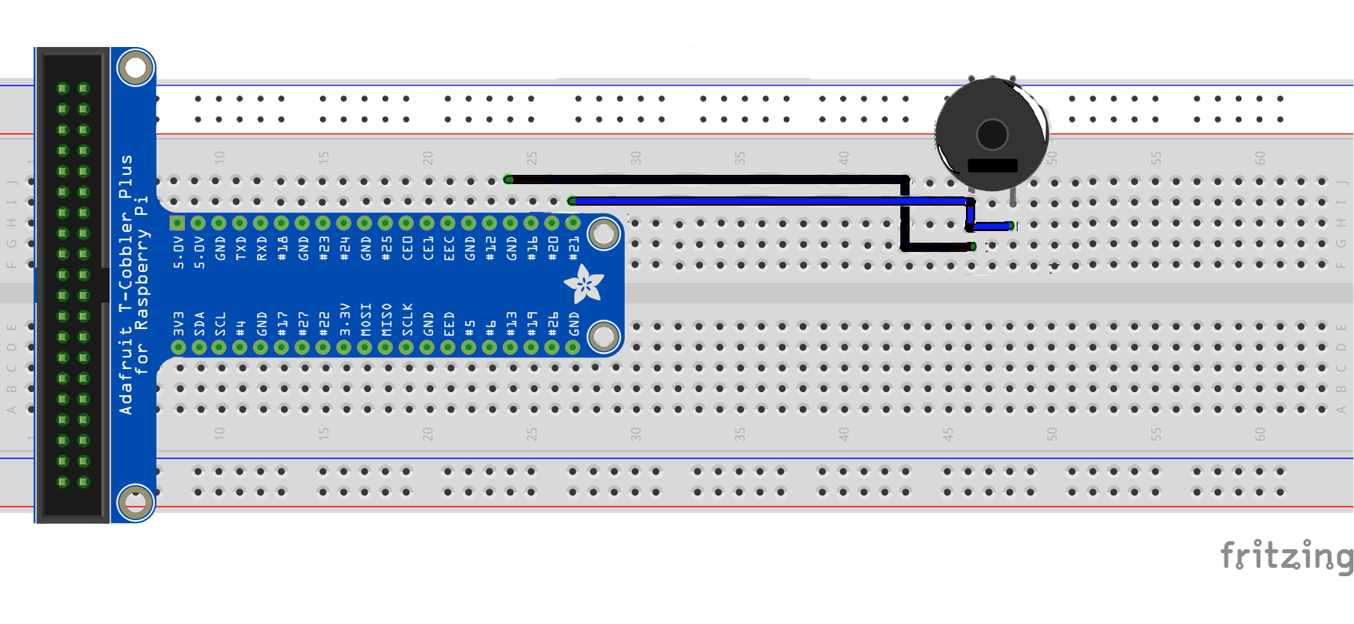

|  | Task | |
| --- | --- | --- |
|  | Connect the Buzzer with the RPi as follows:   |  |  |  | | --- | --- | --- | | **Jumper color** | **PIR pin** | **RPi pin** | | Black | GND | GND | | Blue | VOUT | BCM21 | |  |

The circuit, with both LEDs, buttons and buzzer installed, should look like this:

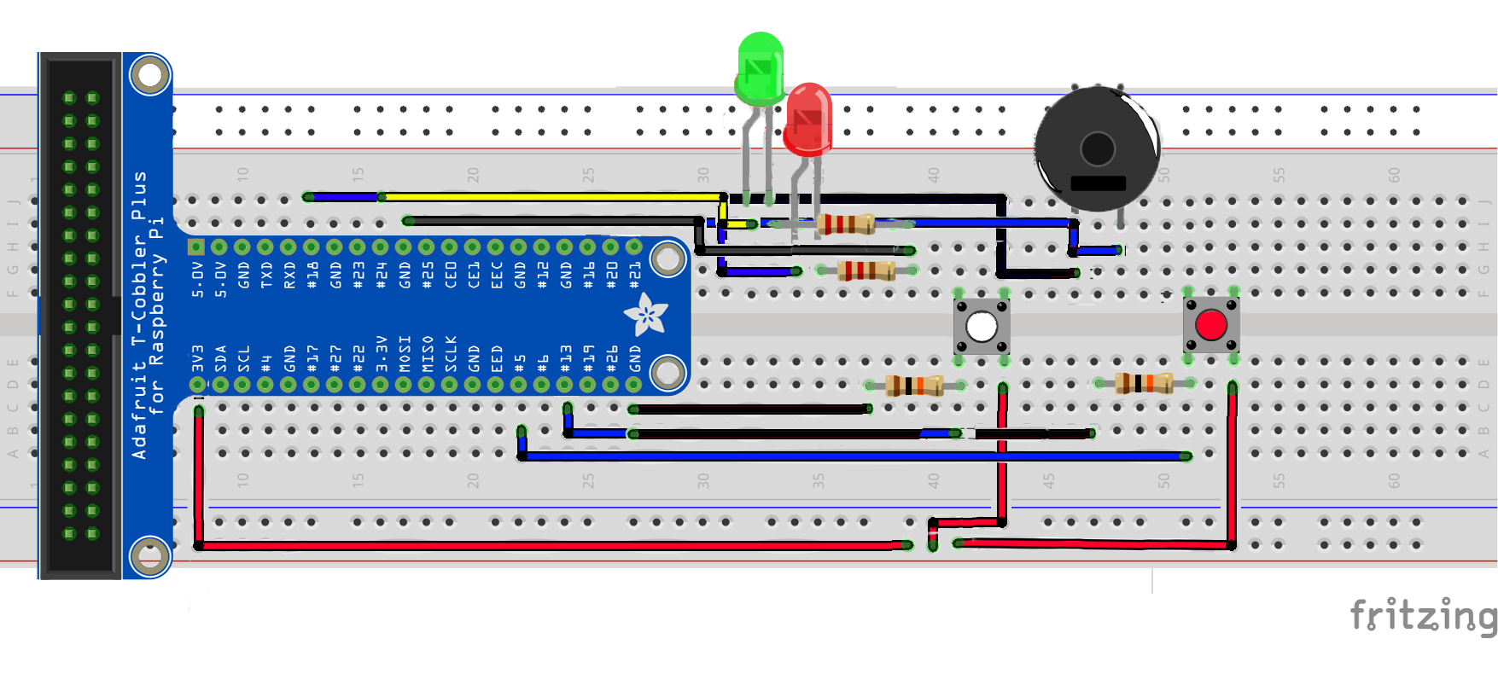

## Installing the DHT11 Sensor

This is how your completed circuit should look like after installing the DHT11 sensor:

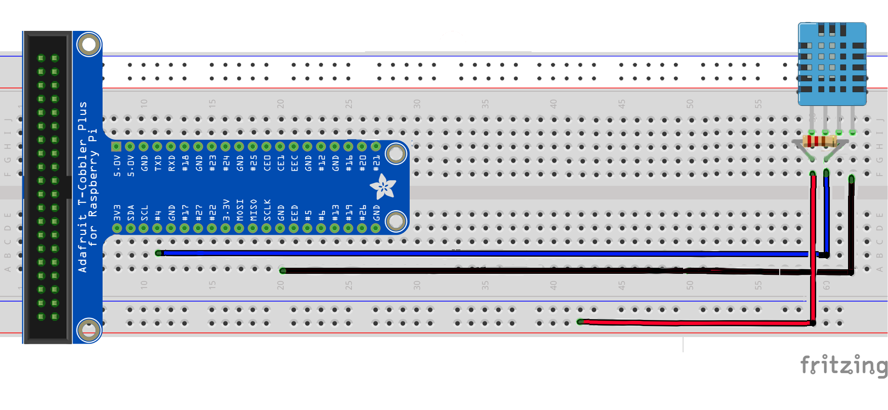

|  | Task |
| --- | --- |
|  | Connect the Buzzer with the RPi as follows:   |  |  |  | | --- | --- | --- | | **Jumper color** | **PIR pin** | **RPi pin** | | Red | VCC | 3V3 | | Blue | DATA | BCM4 | | Red | GND | GND | |

Now, the circuit is almost complete, with one more LED missing:

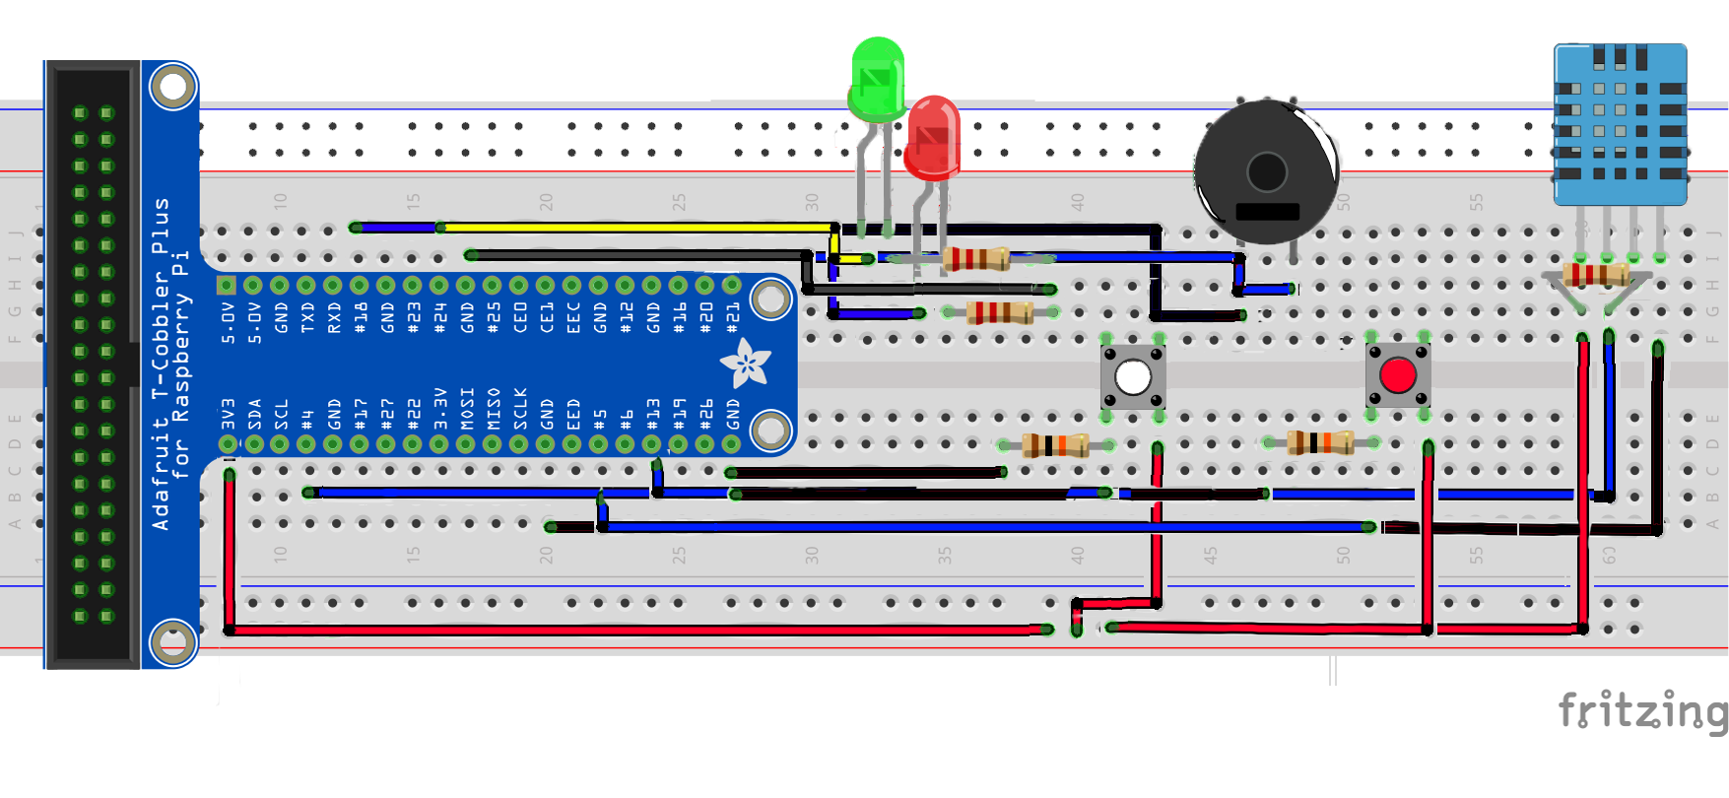

## Installing the Yellow LED

This is how your completed circuit should look like after installing the red LED:

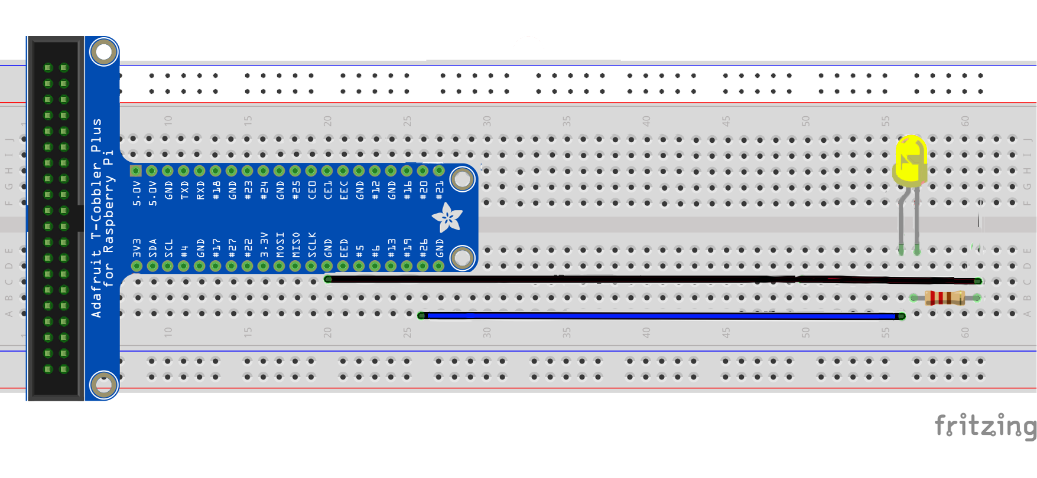

|  |  |
| --- | --- |
| CONNECT RED LED AND RESISTOR | |
|  | Plug in the LED into the breadboard as shown. Place the longer end of the LED nearer to the T-Cobbler Kit. |
|  | Plug in the **330 Ω** resistor into the breadboard as shown. One end of the resistor should be in the same column as the short leg of the LED. |
|  | **LED**   1. Using a **blue** cable, connect the long end of LED to **BCM26** |
|  | **Resistor (Orange-Orange-Brown)**   1. Using a **black** cable, connect the free end of the 330 Ω resistor to GND |

The setup is finally complete!

The circuirt should look like this:

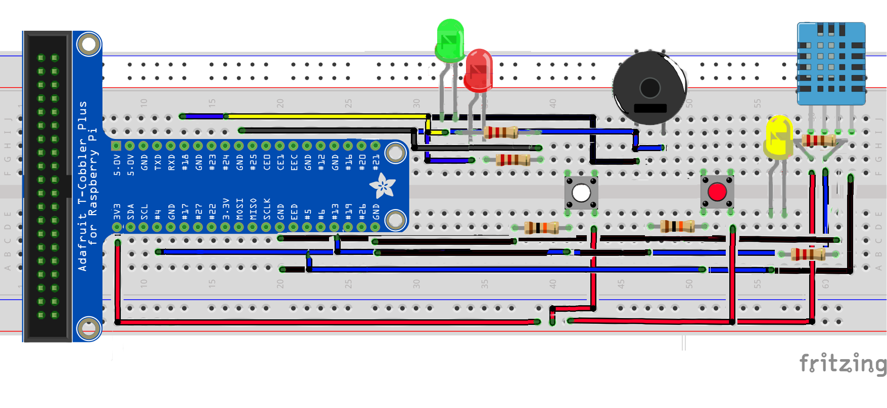

# Section 4 Code the Program

Before we start coding the program, we will be required to install some necessary software.

## Install the Necessary Software

For the facial recognition software, we will be using OpenCV (Open Source Computer Vision Library) with the PiCam.

*Note: The first part of this tutorial is based on an online tutorial by Adrian Rosebrock on pyimagesearch, available at: https://www.pyimagesearch.com/2017/09/04/raspbian-stretch-install-opencv-3-python-on-your-raspberry-pi/*

Firstly, we would need to expand the filesystem to include all the available space on the microSD card. This is because the software takes up quite a big amount of space.



Select ‘Advanced Options’ in the menu and select ‘Expand filesystem’. You will then be guided alont to run through the process of expanding the filesystem. After which, reboot the system.



After rebooting, we will now install the dependencies. After updating and upgrading all existing packages, we will install several developer tools, such as CMake, and several OpenCV requirements.



After the dependencies have been installed, we can now download the OpenCV source code.



We would also need to download the opencv_contrib repository as well, as we will want the full install of OpenCV 3 for all of its various features.



We will also install pip, the Python package manager.



We will be using a virtualenv for our program. This is a standard practice for Python programming, and as such, we will be using it as well.



We will need to add the following to our *~/.profile* file.



In our command prompt, we will need to reload the *~/.profile* file for it to take effect. We can do so by executing:



After this, we can now make our virtualenv in python3.



Refresh the *~/.profile* file once again, and we can work on our newly created virtual environment.



You will know if you are in the virtual environment when you see a “(cv)” at the side of your command line.



Now that we are in the virtual environment, we can install NumPy, used for numerical processing.



After completion, we can finally make, compile and install OpenCV.



Before we compile, we will have to expand the swap space size of the raspberry pi, be editing /etc/dphys-swapfile and changing the ‘CONF_SWAPSIZE’ variable to ‘1024’.

After which, we can restart the swap service by running:



Now, we’re ready to compile OpenCV.



Compiling OpenCV alone will take a very long time, as the Raspberry Pi is not the most powerful of machines. Compiling alone took about 3-4 hours for me personally, while the entire process took me a whole day! After it’s done, we can (finally) install OpenCV 3.



After the install, we should check /usr/local/lib/python3.6/site-packages for the cv2.s file. It should be something along the lines of ‘cv2.cpython-xxxx.so’. However, it should be cv2.so alone instead. Apparently, when installed for python3, it will have this issue. However, it is not difficult to correct that, by just renaming the file.



After renaming, we can sym-link the cv2.so file to our cv virtual environment.



Now, we can change our swapfile back to the original size of 100. Just reverse the process we have done earlier.

*Note: this second part is based off of ‘MJRoBot’/’Mjrovai’s’ tutorial on hackster.io, which is available at:   
https://www.hackster.io/mjrobot/real-time-face-recognition-an-end-to-end-project-a10826*

*However, I modified the code to suit our solution.*

We will also need to download Cascades files, ‘haarcascades’, from the OpenCV Github. This will enable the detection of faces. They are available at:

<https://github.com/opencv/opencv/tree/master/data/haarcascades/>

The specific xml file that we will need is ‘haarcascade_frontalface_default.xml’. It will definitely be alright if you just download that. However, I downloaded all of it to experiment around. These XML files will allow the camera to detect various different things, from eyes, to your full body. These files will be required to be in a folder called ‘haarcascades’ in your project directory.

There are three parts to the facial recognition solution:

* + 1. Face Scanning
    2. Face Training
    3. Face Recognition

Face Scanning, uses the OpenCV software to detect and scan for faces, saving multiple images of the face.

It will then use the Face Training code in order to save the faces into a *.yml* file.

This *.yml* file will then be used by the Face Recognition code to identify the face based off of confidence, meaning that the software will give a percentage of confidence that the face matches the one stored in the *.yml* file.

Now that we have installed the OpenCV software, we can now proceed to install the other software in the virtual environment. As the virtual environment is isolated from the Raspberry Pi’s main raspbian installation, we would also be required to install Flask, gevent, gpiozero, MySQL, and several other important software.



MySQL will prompt you to configure the root passwords and the like. Just follow the guide and it should be alright.

Now that we have installed MySQL, we need to setup the database for our project.



After logging in, we shall create an assignment database.



After which, we will create and assignment user to access the database, giving the user the password ‘joshsmartroom’.



Now, we can log in to the database and create the necessary tables, and insert the necessary data.



The data that we inserted into the Security table is firstly the passcode for the button combinations and the confidence level of the facial recognition that will allow the user to login.

## Code the Program

We can finally start coding the program! For all the codes that we will be writing, it will be a a folder called ‘server’ in the project directory.

Firstly, create a python file called, startprogram.py in the project directory. This will wait for the user to press the red button before they will ask for the button passcode combination.

from gpiozero import Button

from rpi_lcd import LCD

btn2 = Button(5, pull_up=False)

lcd = LCD()

lcd.clear()

while True:

lcd.text("Press Red Button", 1)

lcd.text("To Initiate...", 2)

response = btn2.wait_for_press()

if response is True:

break

lcd.clear()

btn2.close()

import password

Next, we will create a python filed called, password.py, which will read the button input and check the database for the correct password.

# password.py

from gpiozero import Button, Buzzer, LED

from rpi_lcd import LCD

from time import sleep

import subprocess

import MySQLdb

subprocess.call(["sudo", "modprobe", "bcm2835-v4l2"])

lcd = LCD()

btn1 = Button(13, pull_up=False)

btn2 = Button(5, pull_up=False)

buzz = Buzzer(21)

greenled = LED(24)

redled = LED(18)

try:

db = MySQLdb.connect("localhost", "assignmentuser", "joshsmartroom", "assignment")

curs = db.cursor()

print("Successfully connected to database!")

except:

print("Error connecting to mySQL database")

sql = "SELECT Passcode FROM assignment.Security WHERE ID = 1"

curs.execute(sql)

result = curs.fetchall()

result = result[0][0]

password = [int(i) for i in str(result)]

print(password)

userpass = []

def buttonOne():

print("Button 1 pressed")

userPass(1)

def buttonTwo():

print("Button 2 pressed")

userPass(2)

def userPass(number):

print("Number received: " + str(number))

userpass.append(number)

print(userpass)

def checkPass(userpass, password):

#print("CHECKING PASSWORD: " + str(userpass))'

if userpass == password:

result = True

else:

result = False

return result

while True:

lcd.text('Please Enter \nPasscode!', 1)

btn1.when_pressed = buttonOne

btn2.when_pressed = buttonTwo

if len(userpass) == len(password):

lcd.clear()

lcd.text('Authenticating...', 1)

sleep(1)

result = checkPass(userpass, password)

if result is True:

lcd.text('Passcode', 1)

lcd.text('Correct!', 2)

buzz.on()

greenled.on()

sleep(2)

greenled.off()

buzz.off()

lcd.text('Initializing', 1)

lcd.text('Face Scan...', 2)

break

else:

lcd.text('Passcode', 1)

lcd.text('Incorrect!', 2)

buzz.on()

redled.on()

sleep(2)

redled.off()

buzz.off()

userpass = []

elif len(userpass) > len(password):

lcd.clear()

lcd.text('Please Try Again', 1)

sleep(1)

userpass = []

redled.close()

greenled.close()

buzz.close()

btn1.close()

btn2.close()

import faceunlock

Now, create a file called fileunlock.py. This will scan for the user’s face and check if the user is in the database.

#faceunlock.py

import cv2

import numpy as np

import os

import MySQLdb

from rpi_lcd import LCD

from time import sleep

import string

from gpiozero import LED, Buzzer

import time, datetime

from picamera import PiCamera

recognizer = cv2.face.LBPHFaceRecognizer_create()

recognizer.read('../trainer/trainer.yml')

cascadePath = "../haarcascades/haarcascade_frontalface_default.xml"

faceCascade = cv2.CascadeClassifier(cascadePath);

font = cv2.FONT_HERSHEY_SIMPLEX

#iniciate id counter

id = 0

def greenLED():

greenled = LED(24)

greenled.on()

sleep(1)

greenled.off()

greenled.close()

def buzzer():

buzz = Buzzer(21)

buzz.on()

sleep(1)

buzz.off()

buzz.close()

try:

db = MySQLdb.connect("localhost", "assignmentuser", "joshsmartroom", "assignment")

curs = db.cursor()

print("Successfully connected to database!")

except:

print("Error connecting to mySQL database")

sql = "SELECT Username FROM assignment.Users"

curs.execute(sql)

result = curs.fetchall()

userslist = ['None']

for x in result:

userslist.append(result[0][0])

print(userslist)

sql = "SELECT FaceScanConfidence FROM assignment.Security"

curs.execute(sql)

result = curs.fetchall()

setconfidence = int(result[0][0])

# Initialize and start realtime video capture

cam = cv2.VideoCapture(0)

cam.set(3, 640) # set video widht

cam.set(4, 480) # set video height

# Define min window size to be recognized as a face

minW = 0.1*cam.get(3)

minH = 0.1*cam.get(4)

lcd = LCD()

lcd.text('Scanning...', 1)

starttime = time.time()

while True:

confidentint = 0

ret, img =cam.read()

img = cv2.flip(img, -1) # Flip vertically

gray = cv2.cvtColor(img,cv2.COLOR_BGR2GRAY)

faces = faceCascade.detectMultiScale(

gray,

scaleFactor = 1.2,

minNeighbors = 5,

minSize = (int(minW), int(minH)),

)

for(x,y,w,h) in faces:

cv2.rectangle(img, (x,y), (x+w,y+h), (0,255,0), 2)

id, confidence = recognizer.predict(gray[y:y+h,x:x+w])

# Check if confidence is less them 100 ==> "0" is perfect match

if (confidence < 100):

id = userslist[id]

confidentint = round(100 - confidence)

print(confidentint)

confidence = " {0}%".format(round(100 - confidence))

else:

id = "unknown"

confidence = " {0}%".format(round(100 - confidence))

cv2.putText(img, str(id), (x+5,y-5), font, 1, (255,255,255), 2)

cv2.putText(img, str(confidence), (x+5,y+h-5), font, 1, (255,255,0), 1)

#cv2.imshow('camera',img)

if confidentint > setconfidence:

lcd.text('Identity', 1)

lcd.text('Confirmed!', 2)

greenLED()

buzzer()

sleep(2)

lcd.text('Welcome, {}!'.format(id), 1)

sleep(1)

lcd.text('Safe Room', 1)

lcd.text('Unlocked!', 2)

sleep(5)

lcd.clear()

try:

print(id)

sql = "SELECT UserID FROM assignment.Users WHERE Username = '%s'" % (id)

curs.execute(sql)

result = curs.fetchall()

for x in result:

userid = x[0]

sql = "INSERT into UserLog(UserID) VALUES (%d)" % (int(userid))

print(sql)

curs.execute(sql)

db.commit()

print('\nDatabase Modified')

cam.release()

cv2.destroyAllWindows()

except MySQLdb.Error as e:

print(e)

break

nowtime = time.time()

timediff = nowtime - starttime

print(timediff)

if timediff > 30:

cam.release()

cv2.destroyAllWindows()

lcd.text('Identity', 1)

lcd.text('Unconfirmed!', 2)

sleep(5)

try:

name = datetime.datetime.now()

sql = "INSERT into FailedEntryLog(DateTime) VALUES ('%s')" % (name)

print(sql)

curs.execute(sql)

db.commit()

print('\nDatabase Modified')

camera = PiCamera()

camera.capture('../captures/{}.jpg'.format(name))

except MySQLdb.Error as e:

print(e)

break

lcd.clear()

import startprogram

We should also create the programs to scan and train users face into the database. Also, please create a folders ‘trainer’, ‘captures’ and ‘data’ in the project root directory. The following are the codes for ‘faceid.py’ and ‘trainer.py’

# faceid.py

import cv2, os, string, MySQLdb

def face(userid):

cam = cv2.VideoCapture(0)

cam.set(3, 640) # set video width

cam.set(4, 480) # set video height

facedetector = cv2.CascadeClassifier('../haarcascades/haarcascade_frontalface_default.xml')

print("\nInitializing Face Capture. Please look at the camera.")

facecount = 0

while(True):

ret, img = cam.read()

img = cv2.flip(img, -1) # flip video image vertically

gray = cv2.cvtColor(img, cv2.COLOR_BGR2GRAY)

faces = facedetector.detectMultiScale(gray, 1.3, 5)

for (x,y,w,h) in faces:

cv2.rectangle(img, (x,y), (x+w,y+h), (255,0,0), 2)

facecount += 1

progress = facecount / 30 * 100

print("Progress: " + '{0:.2f}'.format(progress) +"%")

# Save the captured image into the datasets folder

cv2.imwrite("../data/UserID-" + str(userid) + '-' + str(facecount) + ".jpg", gray[y:y+h,x:x+w])

k = cv2.waitKey(100) & 0xff

if k == 27:

break

elif facecount >= 30:

break

print("\nCapture Complete")

cam.release()

cv2.destroyAllWindows()

print("\nTraining Faces")

import trainer

# trainer.py

import cv2

import numpy as np

from PIL import Image

import os

path = '../data'

recognizer = cv2.face.LBPHFaceRecognizer_create()

detector = cv2.CascadeClassifier("../haarcascades/haarcascade_frontalface_default.xml");

# function to get the images and label data

def getImagesAndLabels(path):

imagePaths = [os.path.join(path,f) for f in os.listdir(path)]

faceSamples=[]

ids = []

for imagePath in imagePaths:

PIL_img = Image.open(imagePath).convert('L') # convert it to grayscale

img_numpy = np.array(PIL_img,'uint8')

id = int(os.path.split(imagePath)[-1].split("-")[1])

faces = detector.detectMultiScale(img_numpy)

for (x,y,w,h) in faces:

faceSamples.append(img_numpy[y:y+h,x:x+w])

ids.append(id)

return faceSamples,ids

print ("\nTraining Faces. Please wait...")

faces,ids = getImagesAndLabels(path)

recognizer.train(faces, np.array(ids))

# Save the model into trainer/trainer.yml

recognizer.write('../trainer/trainer.yml') # recognizer.save() worked on Mac, but not on Pi

# Print the numer of faces trained and end program

print("\n{0} faces trained. Bye".format(len(np.unique(ids))))

Next, we will create the application that will read the data from the DHT11 sensor and store the data into the database, so we can view it in the webpage later.

#atmosphere.py

import sys

import Adafruit_DHT

from gpiozero import Button, LED, Button

import time

from time import sleep

import MySQLdb

pin = 4

yellowled = LED(26)

button = Button(5)

def ledToggle():

yellowled.toggle()

try:

db = MySQLdb.connect("localhost", "assignmentuser", "joshsmartroom", "assignment")

curs = db.cursor()

print("Successfully connected to database!")

except:

print("Error connecting to mySQL database")

def atmosphere(temperature, humidity):

try:

sql = "INSERT into atmosphere (temperature, humidity) VALUES ('%s', '%s')" % (temperature, humidity)

print(sql)

curs.execute(sql)

db.commit()

except Exception:

print(Exception)

initialtime = time.time()

while True:

button.when_pressed = ledToggle

humidity, temperature = Adafruit_DHT.read_retry(11, pin)

atmosphere(temperature, humidity)

sleep(5)

Now, we can create the server using Flask.

#server.py

import datetime

import gevent

import gevent.monkey

from gevent.pywsgi import WSGIServer

import MySQLdb

gevent.monkey.patch_all()

from flask import Flask, request, Response, render_template

from gpiozero import LED

led = LED(26)

def ledOn():

led.on()

return "Room Light is on."

def ledOff():

led.off()

return "Room Light is off"

def ledStatus():

if led.is_lit:

return 'On'

else:

return 'Off'

app = Flask(__name__)

@app.route("/")

def index():

return render_template('index.html')

@app.route("/readLED/")

def readPin():

response = ledStatus()

templateData = {

'title' : 'Status of LED: ',

'response' : response

}

return render_template('pin.html', **templateData)

@app.route("/writeLED/<status>")

def writePin(status):

if status == 'On':

response = ledOn()

else:

response = ledOff()

templateData = {

'title' : 'Status of LED',

'response' : response

}

return render_template('pin.html', **templateData)

@app.route("/viewAtmosphere/")

@app.route("/viewAtmosphere/realtime/")

def viewAtmosphereRT():

try:

db = MySQLdb.connect("localhost", "assignmentuser", "joshsmartroom", "assignment")

curs = db.cursor()

print("Successfully connected to database!")

except:

print("Error connecting to mySQL database")

query = "SELECT datetimevalue, temperature, humidity FROM atmosphere ORDER BY datetimevalue DESC LIMIT 10"

curs.execute(query)

data = []

for (datetimevalue, temperature, humidity) in curs:

d = []

d.append("{:%H:%M:%S}".format(datetimevalue))

d.append(temperature)

d.append(humidity)

data.append(d)

print(data)

data_reversed = data[::-1]

return render_template('atmosphere.html', data=data_reversed)

@app.route("/viewAtmosphere/historic/")

def viewAtmosphereHistoricRouter():

return render_template('router.html')

@app.route("/viewAtmosphere/historic/<date>")

def viewAtmosphereHistoric(date):

date = str(date)

try:

db = MySQLdb.connect("localhost", "assignmentuser", "joshsmartroom", "assignment")

curs = db.cursor()

print("Successfully connected to database!")

except:

print("Error connecting to mySQL dacon.tabase")

query = "SELECT datetimevalue, temperature, humidity FROM atmosphere WHERE DATE(datetimevalue) = '%s' " % (date)

print(query)

curs.execute(query)

data = []

for (datetimevalue, temperature, humidity) in curs:

d = []

d.append("{:%H:%M:%S}".format(datetimevalue))

d.append(temperature)

d.append(humidity)

data.append(d)

print(data)

data_reversed = data[::-1]

return render_template('atmosphere.html', data=data_reversed)

@app.route("/viewUserLogs/")

def viewUserLogs():

try:

db = MySQLdb.connect("localhost", "assignmentuser", "joshsmartroom", "assignment")

curs = db.cursor()

print("Successfully connected to database!")

except:

print("Error connecting to mySQL dacon.tabase")

query = "SELECT u.Username, l.DateTime FROM Users u INNER JOIN UserLog l ON u.UserID = l.UserID;"

print(query)

curs.execute(query)

data = []

for (username, datetime) in curs:

d = []

d.append(username)

d.append(datetime)

data.append(d)

print(data)

data_reversed = data[::-1]

return render_template('userlog.html', data=data_reversed)

@app.route("/viewFailedEntryLogs/")

def viewFailedEntryLogs():

try:

db = MySQLdb.connect("localhost", "assignmentuser", "joshsmartroom", "assignment")

curs = db.cursor()

print("Successfully connected to database!")

except:

print("Error connecting to mySQL dacon.tabase")

query = "SELECT DateTime, PictureID from FailedEntryLog;"

curs.execute(query)

data = []

for (datetime, pictureid) in curs:

d = []

d.append(datetime)

d.append(pictureid)

data.append(d)

print(data)

data_reversed = data[::-1]

return render_template('failedlogs.html', data=data_reversed)

@app.route("/changePassword/")

def changePassword():

return render_template('changepassword.html')

@app.route("/changePassword/<password>")

def changePasswordDB(password):

password = int(password)

print(password)

try:

db = MySQLdb.connect("localhost", "assignmentuser", "joshsmartroom", "assignment")

curs = db.cursor()

print("Successfully connected to database!")

except:

print("Error connecting to mySQL database")

try:

sql = "UPDATE Security SET Passcode = %d WHERE ID = 1;" % (password)

print(sql)

curs.execute(sql)

db.commit()

print('\nDatabase Modified')

except MySQLdb.Error as e:

print(e)

return render_template('passwordchanged.html')

@app.route("/registerFace/")

def registerFaceForm():

return render_template('facescan.html')

@app.route('/registerFace/<userid>/<username>')

def registerFace(userid, username):

from faceid import face

face(userid)

try:

db = MySQLdb.connect("localhost", "assignmentuser", "joshsmartroom", "assignment")

curs = db.cursor()

print("Successfully connected to database!")

except:

print("Error connecting to mySQL database")

try:

sql = "INSERT into Users(UserID, Username) VALUES ('%d', '%s')" % (int(userid), str(username))

curs.execute(sql)

db.commit()

print('\nDatabase Modified')

except MySQLdb.Error as e:

print(e)

return render_template('faceregistered.html')

@app.route("/changeFaceUnlockConfidence/")

def changeConfidence():

return render_template('changeconfidence.html')

@app.route("/changeFaceUnlockConfidence/<value>")

def changeConfidenceDB(value):

value = int(value)

try:

db = MySQLdb.connect("localhost", "assignmentuser", "joshsmartroom", "assignment")

curs = db.cursor()

print("Successfully connected to database!")

except:

print("Error connecting to mySQL database")

try:

sql = "UPDATE Security SET FaceScanConfidence = %d WHERE ID = 1;" % (value)

print(sql)

curs.execute(sql)

db.commit()

print('\nDatabase Modified')

except MySQLdb.Error as e:

print(e)

return render_template('confidencechanged.html')

if __name__ == '__main__':

try:

http_server = WSGIServer(('0.0.0.0', 8001), app)

app.debug = True

http_server.serve_forever()

except:

print("Exception")

We would also need to create the HTML templates for the server to host. The following codes are stored in a folder in /server/templates.

#atmosphere.html

<!doctype html>

<head>

<title>Smart Safe Room Atmosphere</title>

<script type="text/javascript" src="https://code.jquery.com/jquery-3.2.1.js"></script>

<script type="text/javascript" src="https://www.google.com/jsapi"></script>

<script type="text/javascript">

google.load('visualization', '1', {'packages':['corechart']});

google.setOnLoadCallback(drawChart);

function drawChart() {

var data = new google.visualization.DataTable();

data.addColumn('string', 'Date');

data.addColumn('number', 'Temperature');

data.addColumn('number', 'Humidity');

data.addRows([

{%- for datetimevalue, temperature, humidity in data %}

['{{ datetimevalue }}', {{ temperature }}, {{ humidity }}],

{%- endfor %}

]);

var chart = new google.visualization.LineChart(

document.getElementById('chart_div'));

chart.draw(data, {legend: 'none', vAxis: {baseline: 0},

colors: ['#00C7CE', '#2200BC']});

}

</script>

<script>

$(document).ready(function () {

setInterval(function () {

location.reload();

//drawChart();

}, 3000);

});

</script>

</head>

<body>

<div id="content">

<h1>Atmosphere Values Captured</h1>

<div id="chart_div"></div>

<div>

<table border="1">

<tr>

<th>Date/Time</th>

<th>Temperature (C)</th>

<th>Humidity (%)</th>

{%- for datetimevalue, temperature, humidity in data %}

<tr>

<td>{{ datetimevalue }}</td>

<td>{{ temperature }}</td>

<td>{{ humidity }}</td>

</tr>

{%- endfor %}

</table>

</div>

<a href="/">Go Back</a>

</div>

</body>

</html>

# changeconfidence.html

<!DOCTYPE html>

<head>

<title>Change Face Unlock Confidence</title>

</head>

<body>

<h3>Change Face Unlock Confidence: </h3>

<p>Please Enter a Value (0-100)</p>

<form id="routeform" onSubmit="route();">

<input type="number" name="number" id="number"/>

<input type="button" id="submit" value="Submit"/>

</form>

<a href="/">Go Back</a>

</body>

<script>

var submit = document.getElementById('submit');

submit.addEventListener('click', function() {

console.log("clicked")

var number = document.getElementById('number').value;

var url = window.location.href.concat(number);

window.location = url;

console.log(url);

})

</script>

</html>

# changepassword.html

<!DOCTYPE html>

<head>

<title>Change Password</title>

</head>

<body>

<h3>Change Password: </h3>

<p>Please Enter a Password Combination (Either 1 or 2)</p>

<form id="routeform" onSubmit="route();">

<input type="number" name="password" id="password"/>

<input type="button" id="submit" value="Submit"/>

</form>

<a href="/">Go Back</a>

</body>

<script>

var submit = document.getElementById('submit');

submit.addEventListener('click', function() {

console.log("clicked")

var password = document.getElementById('password').value;

var url = window.location.href.concat(password);

window.location = url;

console.log(url);

})

</script>

</html>

# confidencechanged.html

<!DOCTYPE html>

<head>

<title>Confidence Changed</title>

</head>

<body>

<h1>Josh Smart Safe Room</h1>

<h2>Confidence Changed</h2>

<a href="/">Go Back</a>

</body>

</html>

# faceregistered.html

<!DOCTYPE html>

<head>

<title>Face Registereds</title>

</head>

<body>

<h1>Josh Smart Safe Room</h1>

<h2>Face Registered</h2>

<a href="/">Go Back</a>

</body>

</html>’

#facescan.html

<!DOCTYPE html>

<head>

<title>Face Scan</title>

</head>

<body>

<h1>Face Scan</h1>

<form id="routeform" onSubmit="route();">

Enter the User ID:<input type="number" name="id" id="id"/>

<br>

Enter the Username:<input type="text" name="username" id="username"/>

<br>

<input type="button" id="submit" value="Submit"/>

</form>

<a href="/">Go Back</a>

</body>

<script>

var submit = document.getElementById('submit');

submit.addEventListener('click', function() {

//console.log("clicked")

var userid = document.getElementById('id').value;

var username = document.getElementById('username').value;

var url = window.location.href.concat(userid).concat('/').concat(username);

window.location = url;

console.log(url);

})

</script>

</html>

# failedlogs.html

<!DOCTYPE html>

<head>

<title>Failed Entry Logs</title>

</head>

<body>

<div>

<h3>Failed Entry Logs</h3>

<p>All Failed Entries will be logged here.</p>

<table border="1">

<tr>

<th>Date/Time</th>

<th>Image Capture</th>

{%- for datetime, pictureid in data %}

<tr>

<td>{{ datetime }}</td><td><img src="../../captures/'{{ pictureid }}.jpg'" alt="{{ pictureid }}"></img></td>

</tr>

{%- endfor %}

</table>

<a href="/">Go Back</a>

</div>

</body>

</html>

#index.html

<!DOCTYPE html>

<head>

<title>{{ title }}</title>

<script src="https://ajax.googleapis.com/ajax/libs/jquery/3.2.0/jquery.min.js"></script>

<script>

function turnon(){

$.ajax({url: "writeLED/On", success: function(result){

$("#status").html(result);

}

})

}

function turnoff(){

$.ajax({url: "writeLED/Off",

success: function(result){

$("#status").html(result);

}

})

}

$(document).ready(function(){

$("#b1").click(function(){

turnon();

});

$("#b2").click(function(){

turnoff();

});

});

</script>

</head>

<body>

<h1>Josh Smart Safe Room</h1>

<div>

<h3>Room Light Switch: </h3>

<p id="status"></p>

<button id="b1">Turn on</button>

<button id="b2">Turn off</button>

</div>

<div>

<h3>Room Atmosphere (Temperature/Humidity): </h3>

<a href="/viewAtmosphere/realtime">View Real Time Room Atmosphere</a>

<br>

<a href="/viewAtmosphere/historic">View Historic Room Atmosphere</a>

</div>

<div>

<h3>Room Entry Logs: </h3>

<a href="/viewUserLogs/">View User Logs</a>

<br>

<a href="/viewFailedEntryLogs/">View Failed Entry Logs</a>

</div>

<div>

<h3>Security Settings: </h3>

<a href="/changePassword/">Change Password</a>

<br>

<a href="/changeFaceUnlockConfidence/">Change Face Unlock Confidence</a>

<br>

<a href="/registerFace/">Register Face Unlock</a>

</div>

</body>

</html>

#passwordchanged.html

<!DOCTYPE html>

<head>

<title>Password Changed</title>

</head>

<body>

<h1>Josh Smart Safe Room</h1>

<h2>Password Changed</h2>

<a href="/">Go Back</a>

</body>

</html>

#pin.html

<!DOCTYPE html>

<head>

<title>{{ title }}</title>

</head>

<body>

{{ response }}

</body>

</html>

#router.html

<!DOCTYPE html>

<head>

<title>Atmosphere History</title>

</head>

<body>

<h1>Josh Smart Safe Room</h1>

<form id="routeform" onSubmit="route();">

<input type="date" name="date" id="date"/>

<input type="button" id="submit" value="Submit"/>

</form>

<a href="/">Go Back</a>

</body>

<script>

var submit = document.getElementById('submit');

submit.addEventListener('click', function() {

//console.log("clicked")

var date = document.getElementById('date').value;

console.log(date);

var url = window.location.href.concat(date);

window.location = url;

console.log(url);

})

</script>

</html>

# userlog.html

<!DOCTYPE html>

<head>

<title>User Entry Logs</title>

</head>

<body>

<div>

<table border="1">

<tr>

<th>User</th>

<th>Date/Time Accessed</th>

{%- for username, datetime in data %}

<tr>

<td>{{ username }}</td>

<td>{{ datetime }}</td>

</tr>

{%- endfor %}

</table>

<a href="/">Go Back</a>

</div>

</body>

</html>

# Section 5 Testing the Software

* 1. atmosphere.py

This is actually the only program that is not required to be run in the virtual environment.

Run it by going into the server folder and type:



You should get a similar output:

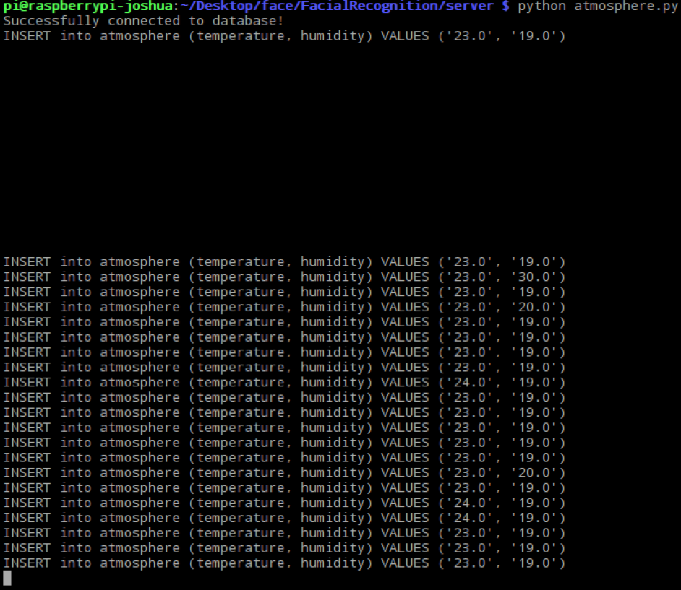

* 1. startprogram.py

This is the script to run to start off the passcode and face unlock security feature. It is designed to loop back every time a user logs in, which means that the program by right should be running forever.



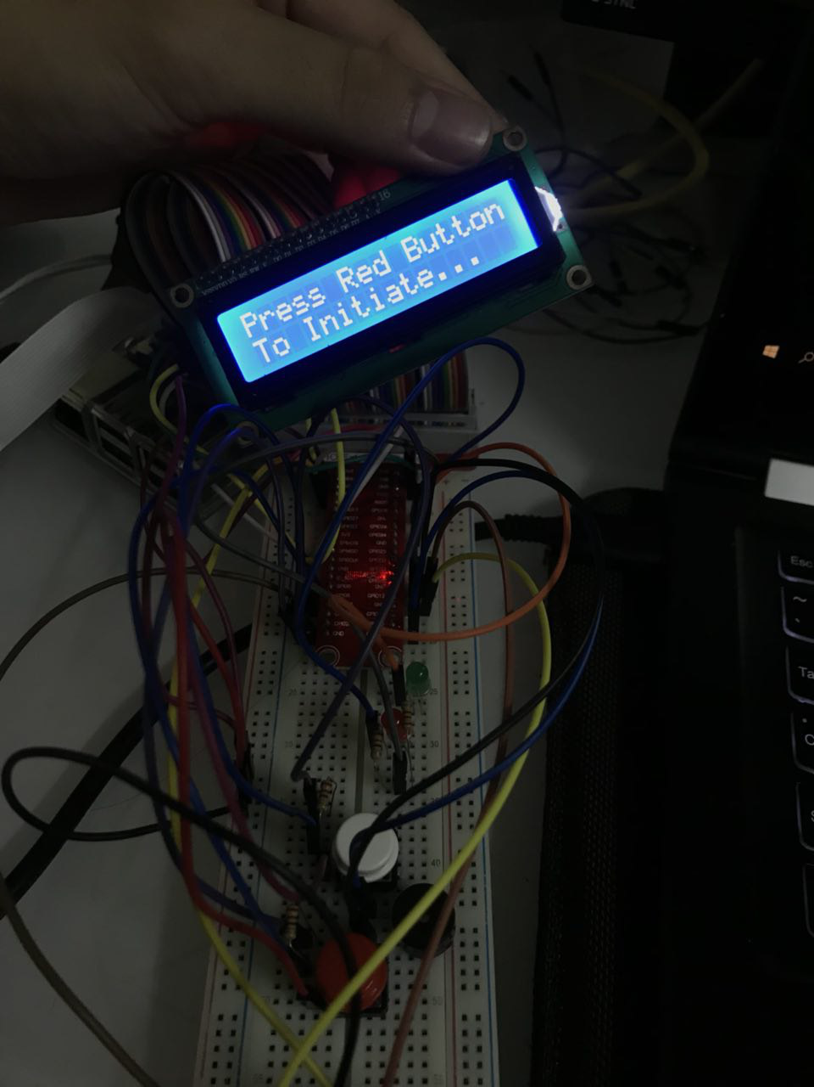

It will prompt the user to press the red button to initiate and asks for the passcode.

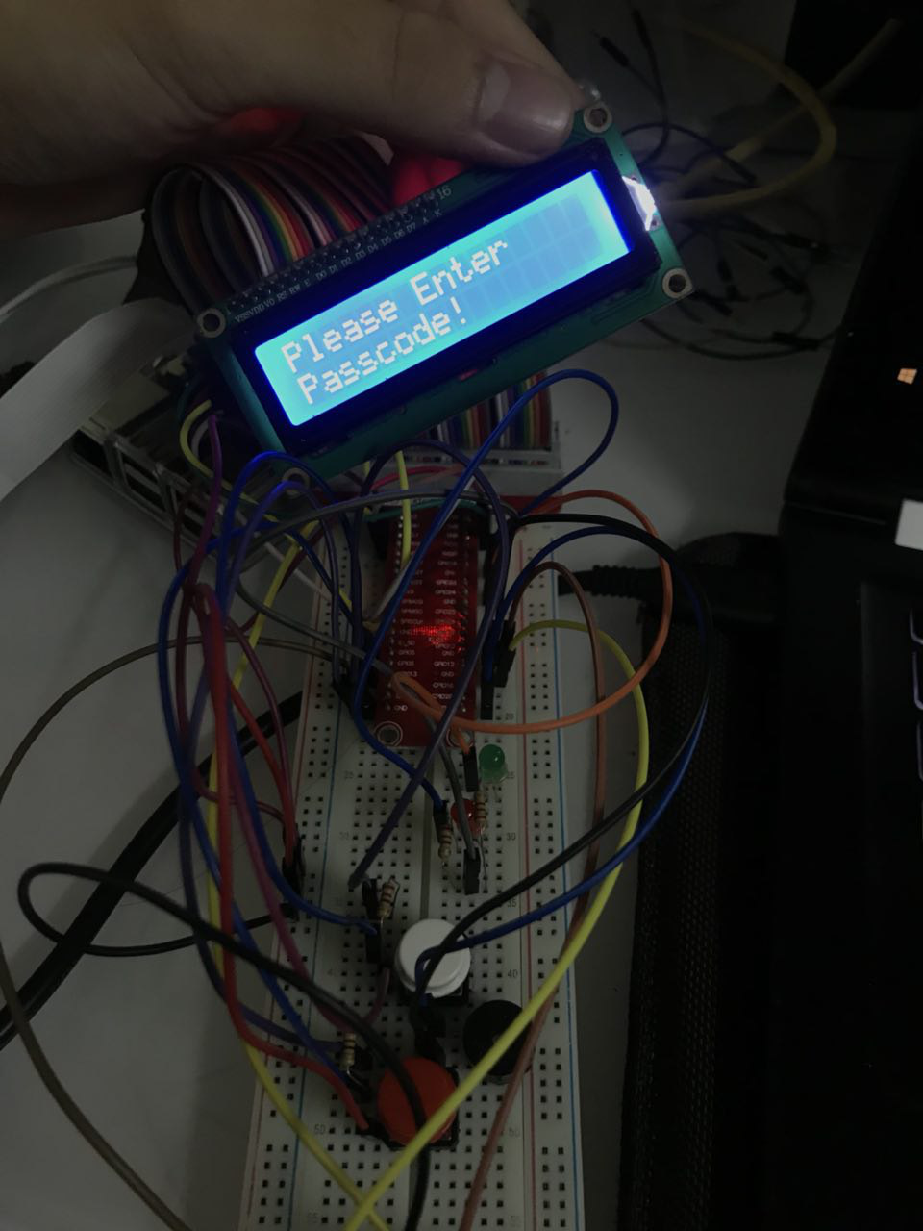

After inputting the correct passcode, it will initiate the face scan.

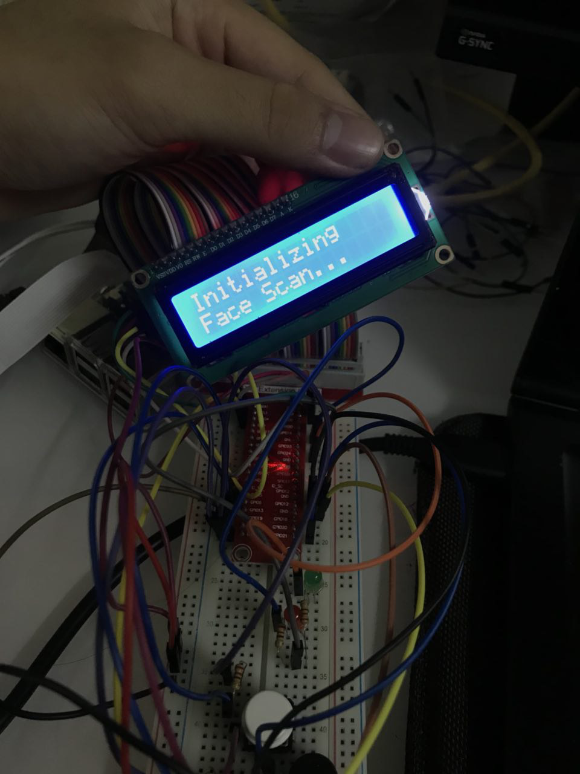

However, we have not yet scanned a face into the database. We shall now test the server to do so.

* 1. server.py

Run the server by typing:



We can now attempt to access the webpage by going to localhost:8001.

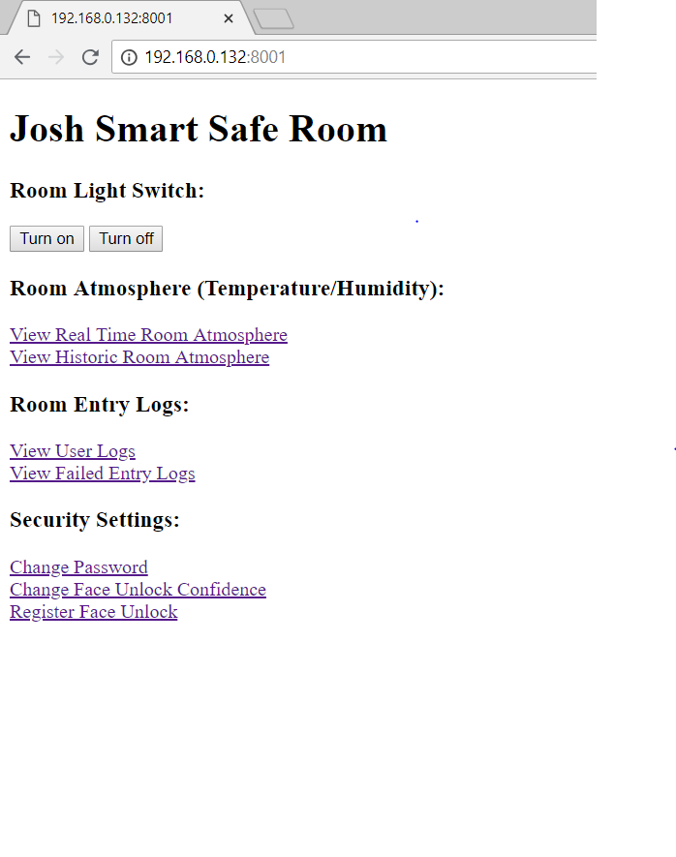

On the frontpage, we can turn the room lights on and off, view the temperature and humidity values of the room, view the entry logs, change the password and face unlock confidence or register a face.

Clicking on the reigster face link, we will be directed to this form to input the user’s ID and their username for the record.

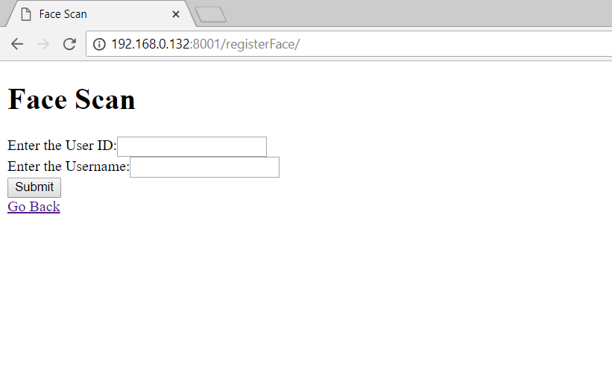

After which, the camera will scan for faces. It may take awhile depending on the lighting, and after which, it will redirect to the page that confirms that the face is registered.

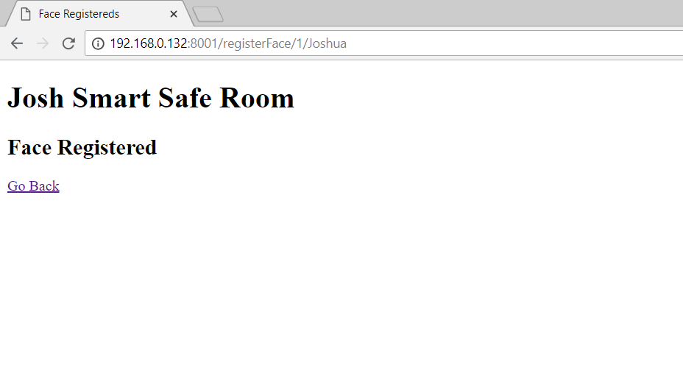

We can also view the humidity values of a certain date, or the latest values.



We could pull out the values from the database of a certain date, using the form given.

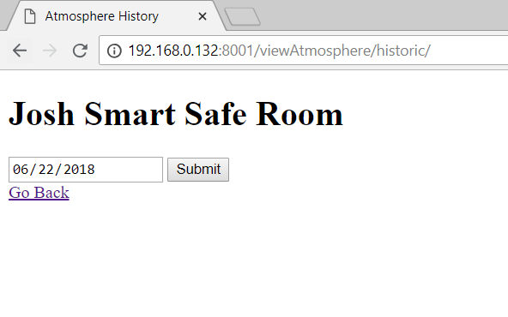

There will also be a log of the users who have entered the room, with the time and date of their entry.

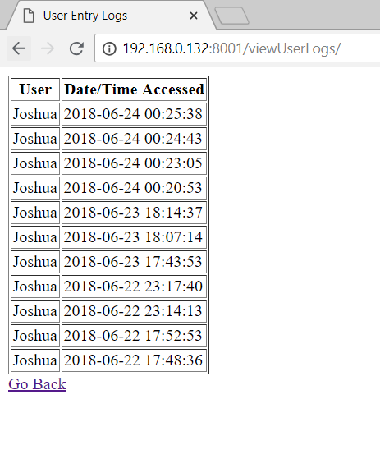

Failed login attempts are also recorded with the image. However, the images are not able to show due to the security of the web browsers.

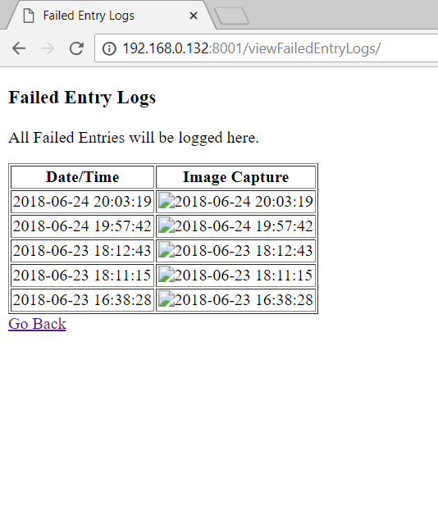

There is also a form that allows the user to change the button combination passcode to enter the room, or the confidence of the facial recognition.

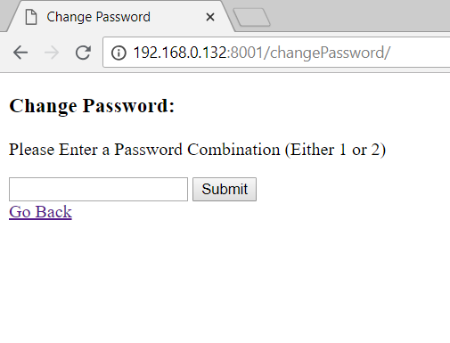

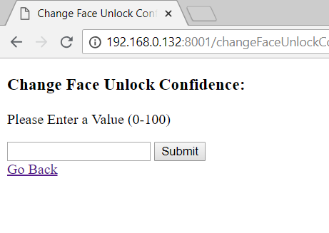

Now that we have registered our face into the database, we can now attempt to enter. The LCD Screen will first greet you by your username, and inform you that the safe room is unlocked.

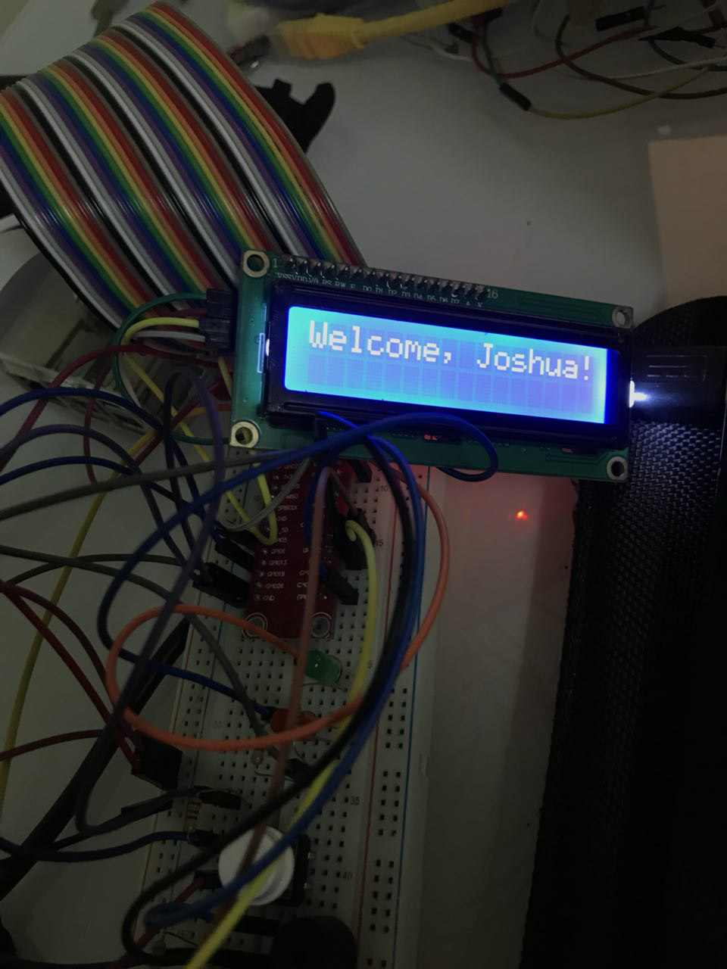

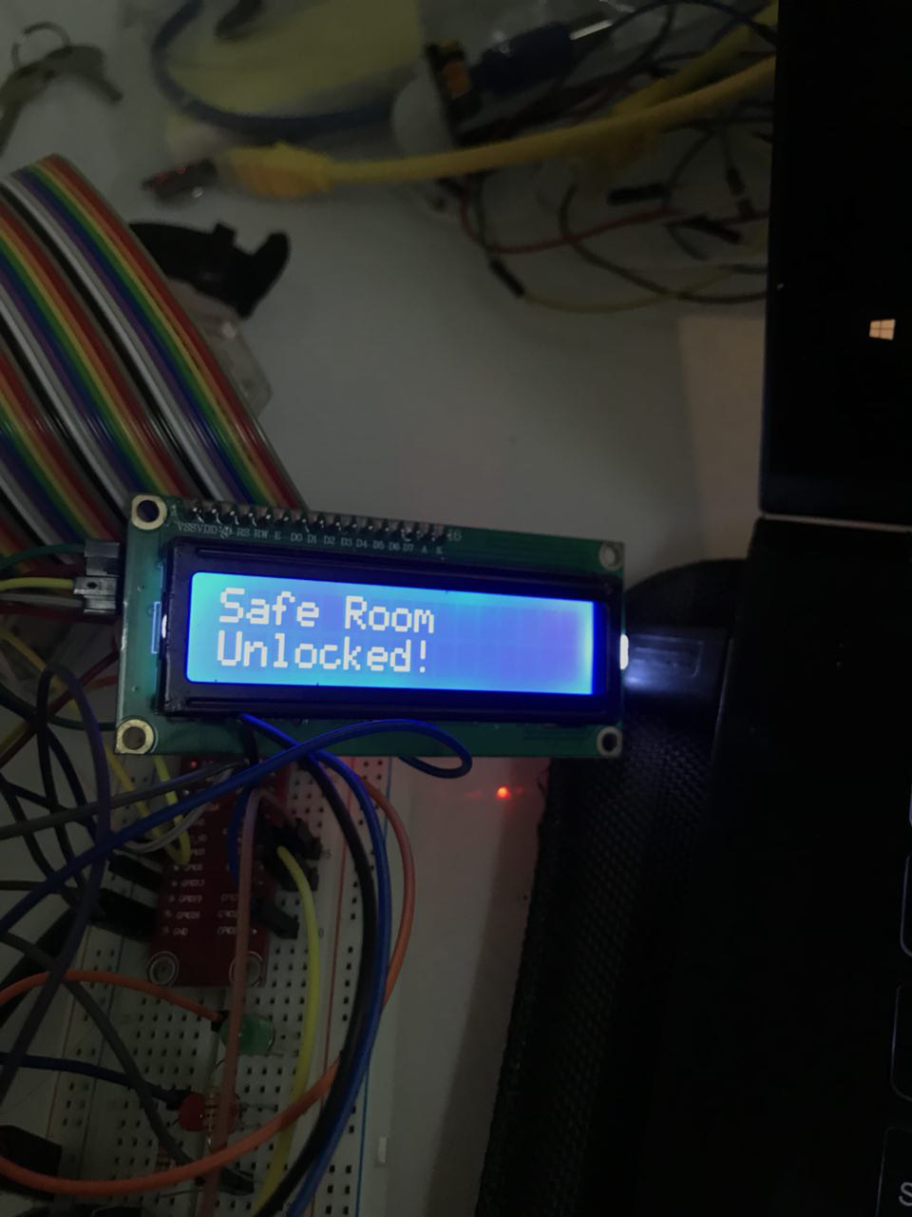

*All source codes, images and resources are available on my GitHub.*

*Available at: github.com/joshualeejunyi/IOTCA1*

**-- End of CA1 Step-by-step tutorial --**